Name

Mathematics Stage 5 Path
Graphs of
Rates of Change

Book 2 | Analyse graphs of constant and variable rates of change | Version: 260511  Feedback:  https://MrDingMaths.com
Contents
Syllabus Content 2
Learning Intention 3

Syllabus Content
MA5-RAT-P-02 analyses and constructs graphs relating to rates of change
Analyse graphs that are decreasing or increasing at a constant rate
- Describe direct variation graphs as increasing at a constant rate and interpret the gradient of the line as the rate of change
- Interpret and analyse further graphs that exhibit a constant rate of change, including those that are decreasing at a constant rate
Analyse the relationship between graphs and variable rates of change
- Interpret distance–time graphs when the speed is variable, describing the rate of increase or decrease, the initial and final points, constant relationships represented by straight lines and variable relationships represented by curved lines
- Describe the rate of change between variables in a variety of contexts including direct and inverse variation
- Describe qualitatively the rate of change of a graph, using terms such as increasing at a decreasing rate
Construct graphical representations of rates of change
- Represent a given description of a variable rate of change of one quantity over time

Rate from a Direct Variation Model

- The Gradient is the Rate
A rate compares two quantities.
When two variables are in a straight-line relationship, the gradient is the rate $y$ per $x$.
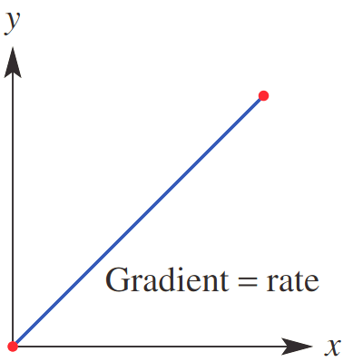
$y=kx$
constant of variation
(gradient)

- Guided Practice
Calculate the gradient, then describe its meaning in each of these direct variation graphs.
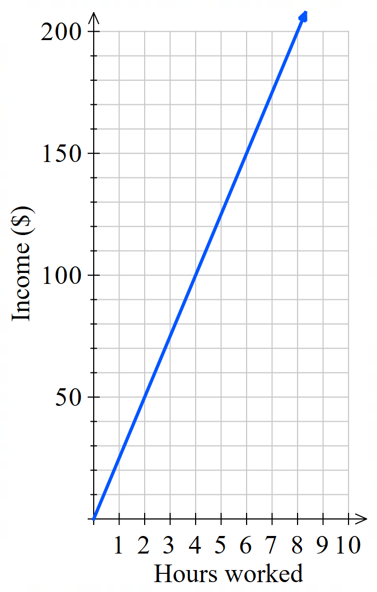  Gradient:  $$m=\frac{rise}{run}=$$  Meaning:  …………… per ………… | 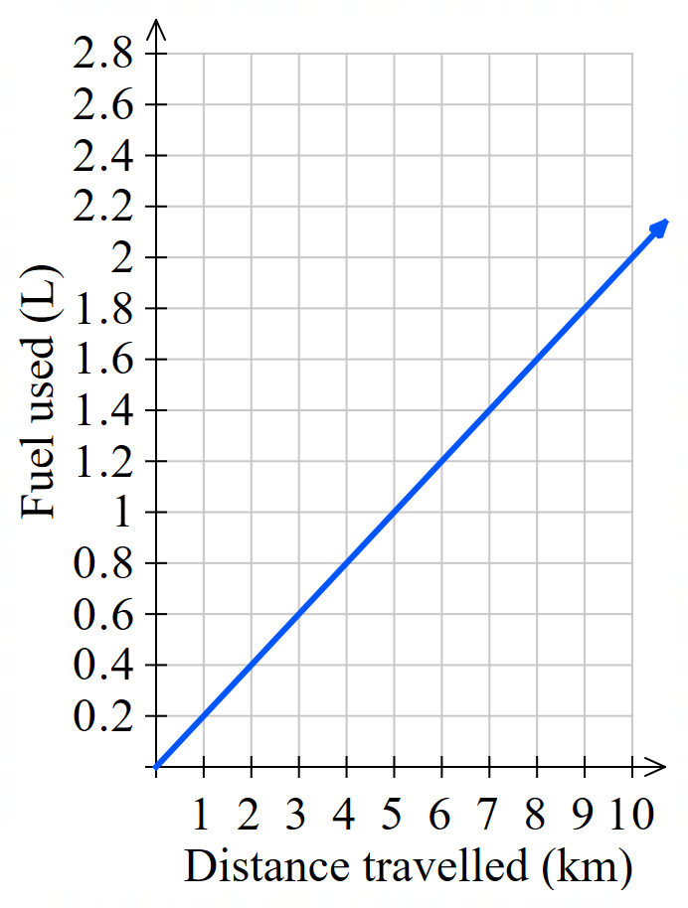  0.2 L per km | 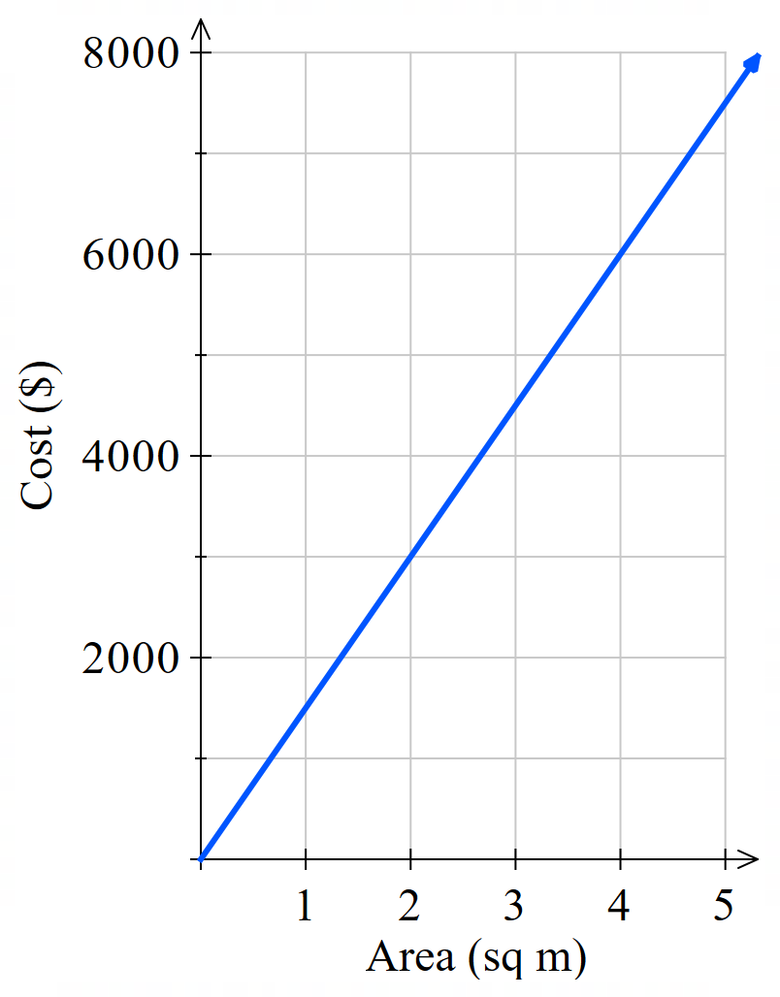  $1500 per sq m

Foundation
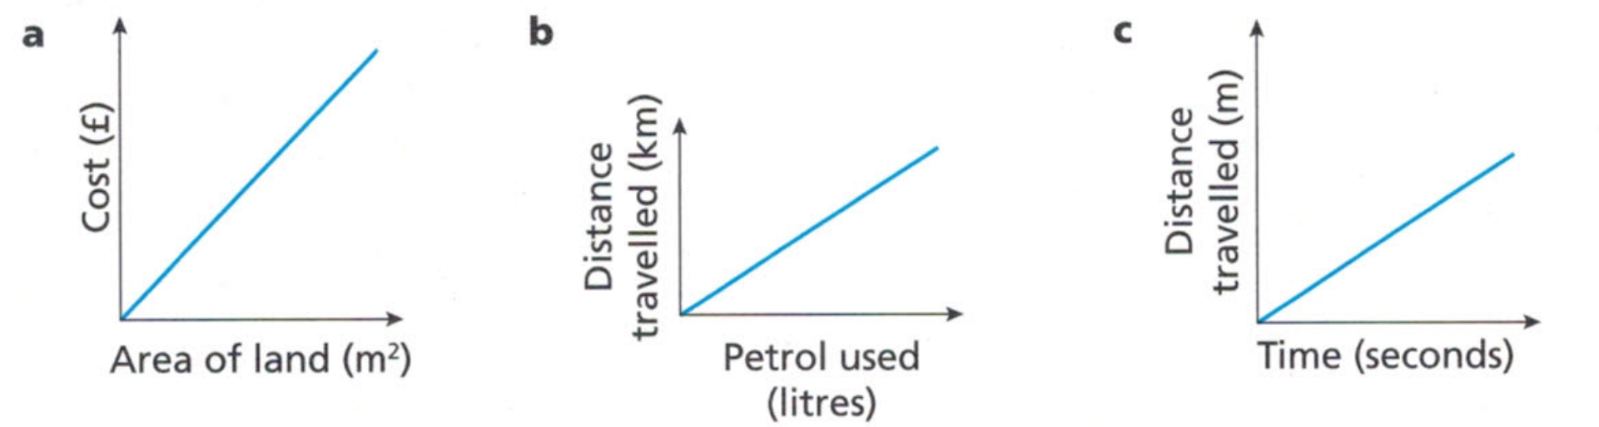
- Here are some direct variation graphs. Describe what the gradient of each line represents.
…………… per ………………  £ per sq metre | km per litre | metres per second

- Use the gradient to find the rate of change of distance over time (speed) for these graphs.
Use the units given on each graph.
100 km/h | 7 cm/s | 2.5 cm/min | 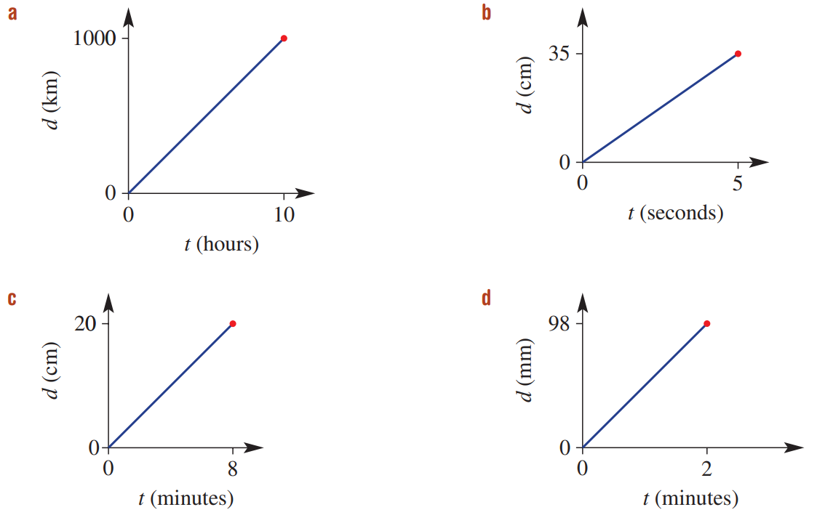  49 mm/min

- Calculate the gradient of each line graph then describe what it represents.
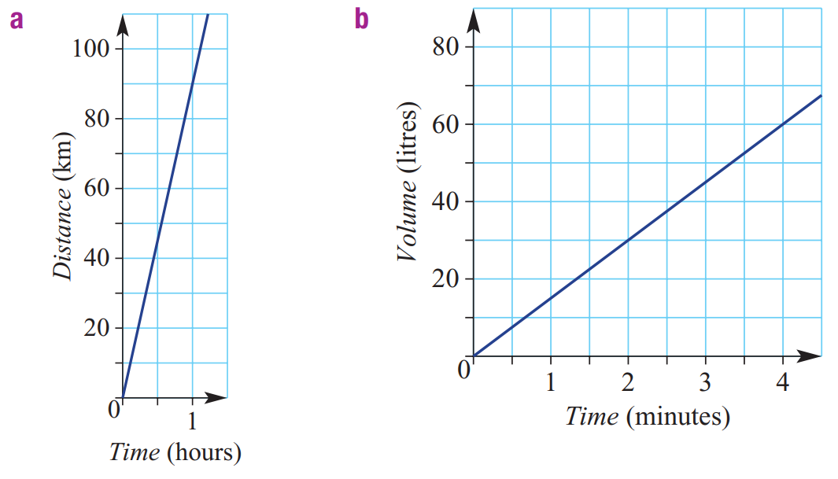  90 km/h | 15 L/min

Analysing Direct Variation with Graphs

- Example Analyse a direct variation relationship
Mr Ding used to work at McDonalds and was paid $20 an hour.
The number of hours he works and his pay are directly proportional.
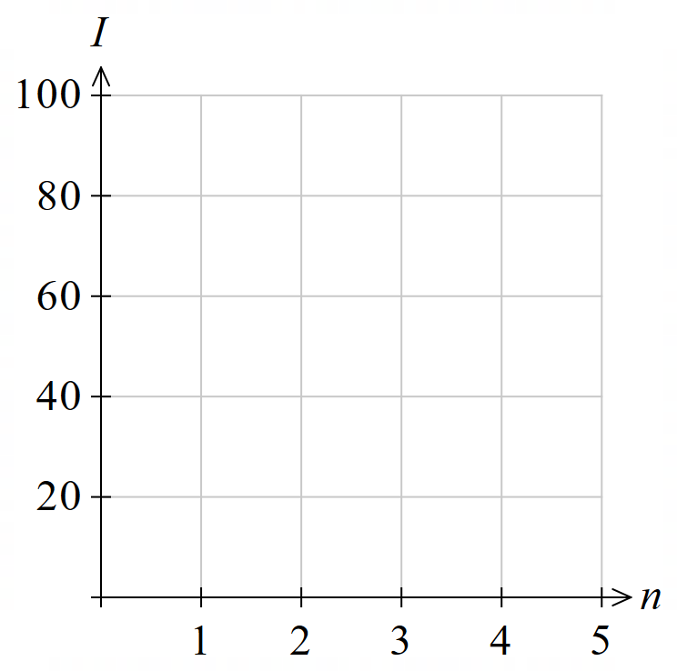
Complete the table of values and draw the graph.
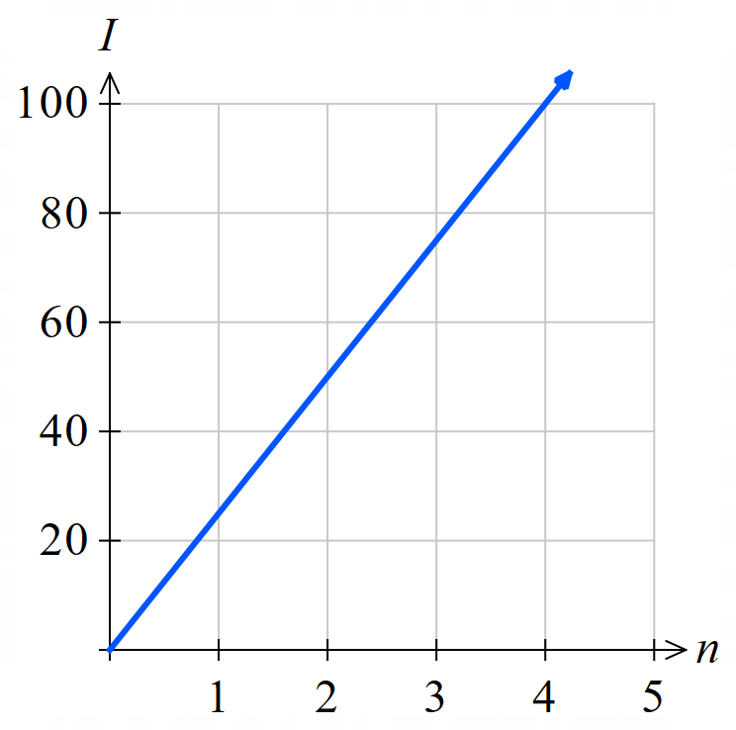
Number of hours $n$ | 0 | 1 | 2 | 3
Income $I$ | 0 | 20 | 40 | 60

Find the gradient, which is the constant of variation $k$.
$$\frac{rise}{run}=20$$

What does $k$ represent in this context?
Pay per hour.

Write an equation relating ($I$) and ($n$).
$y=kx$
$I=20n$

Find his income for 15 hours of work.
$I=20\left(15\right)$
$=300$

Mr Ding wants to buy a PS5 costing $650. Find how long he must work to earn it.
$650=20n$
$$\frac{650}{20}=n$$
$=32.5$ hours

- Guided Practice
- Pens cost $1.50 per pack. Complete the table of values for number of packs $N$ and price $P$
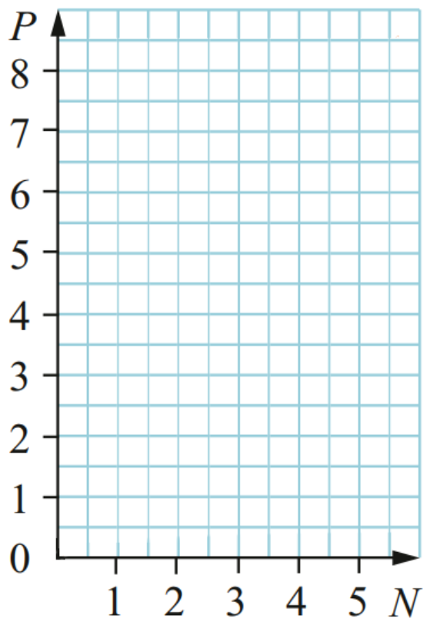
Complete the table and sketch the graph.
$$N$$ | 0 | 1 | 2 | 3
$$P$$
0, 1.5, 3, 4.5
Find the gradient, which is the constant of variation $k$.

1.5
What does $k$ represent in this context?

Cost per pack
Write the equation relating $P$ and $N$.

$P=1.5N$
Find the cost of 9 packs of pencils.

$13.50
How many packs can be bought for $\$27$?

18 packs
- The graph shows distance over time for an express interstate train.
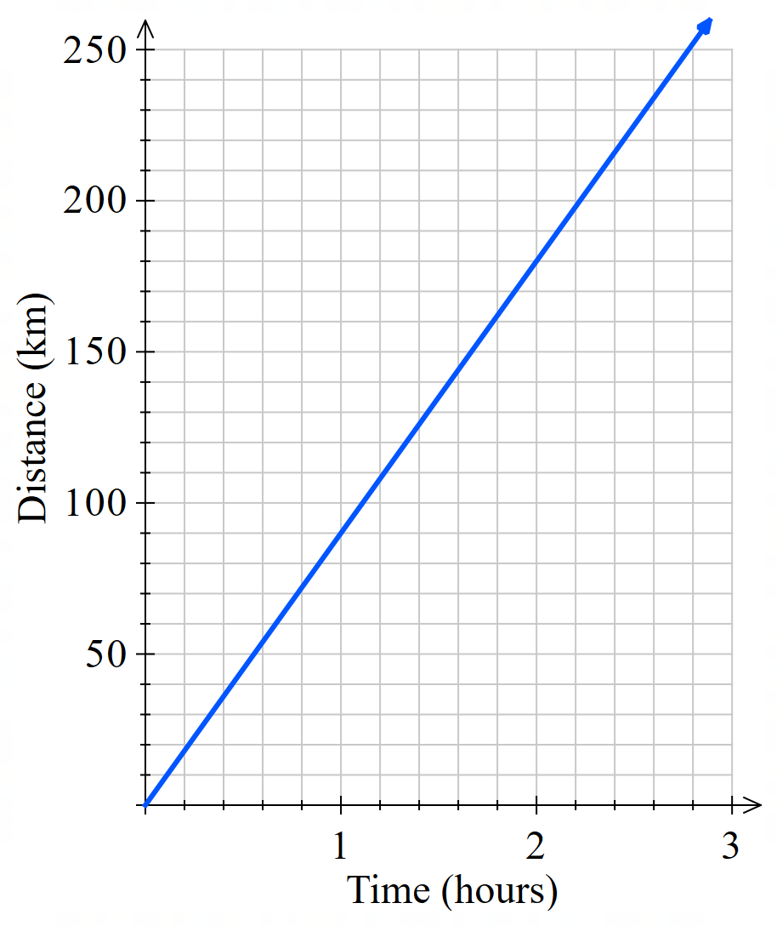
Find the gradient, the constant of variation $k$.

90
What does $k$ represent in this context?

Speed in km/h
Write an equation relating $d$ and $t$.

$d=90t$
How far would the train travel in 12 hours?

1080 km
How long would it take to travel between Sydney and Adelaide, a distance of 1260 km?

14 h

Foundation
- The rule linking the height of a plant over time is given by $h=5t$,
where $h$ is in millimetres and $t$ is in days.
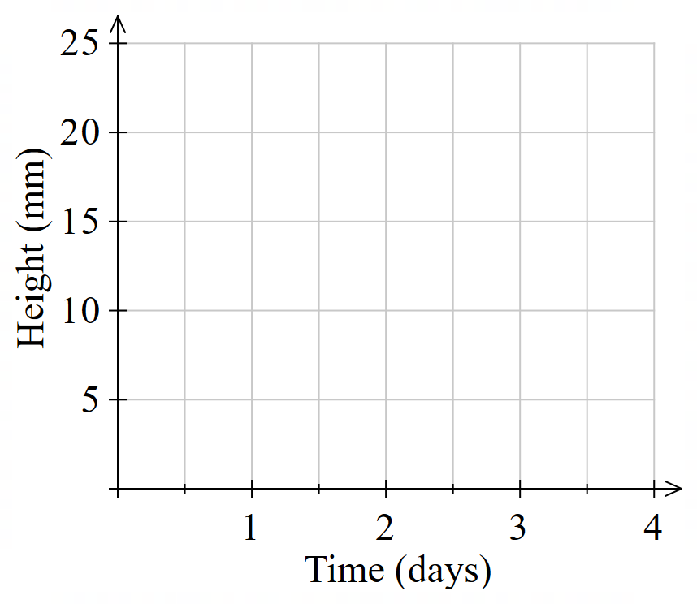
  - Complete the table and graph the relationship.
$$t$$ | 0 | 1 | 2 | 3 | 4
$$h$$

  - What is the gradient of the graph and
how does it relate to the equation?

5. It is the coefficient of the independent variable $t$.
  - What rate does the gradient represent?

The plant grows 5 mm per day

- The distance, $d$ kilometres, travelled by a train in a time of $t$ hours is $d=80t$
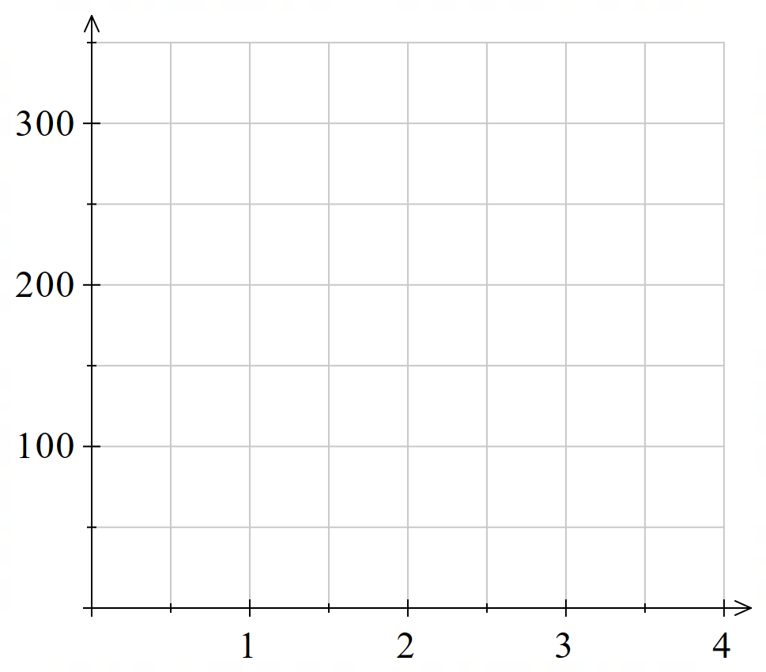
  - Complete this table of values using the equation $d=80t$ and draw the graph.
$$t$$ | 0 | 1 | 2 | 3 | 4
$$d$$
0, 80, 160, 240, 320
  - What is the gradient and what does it represent?

80, kilometres per hour
  - Use the graph to find the distance of the train after 3.5 hours.

280 km
  - Use the graph to find when the train is 200 km away.

2.5 h
- The Supertight Tie Company sells ties for $15 each.
The sales revenue may be modelled using the equation $R = 15n$.
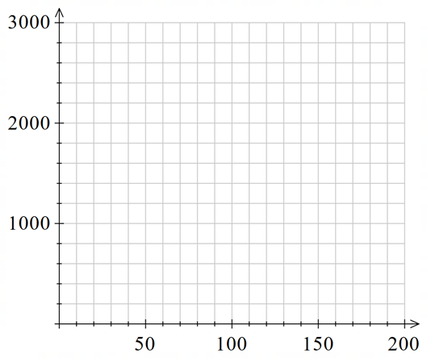
  - Draw the graph of $R = 15n$.
Remember to label the axes.
$$n$$ | 0 | 50 | 100 | 150 | 200
$$R$$
0, 750, 1500, 2250, 3000
  - Find the gradient, which is the constant of
variation $k$.

15
  - What does $k$ represent in this scenario?

Revenue per tie
  - Use the graph to find many ties need to be sold to make $1800 in revenue.

Reading from the graph, 120

- The graph shows the cost of buying a given number of books,
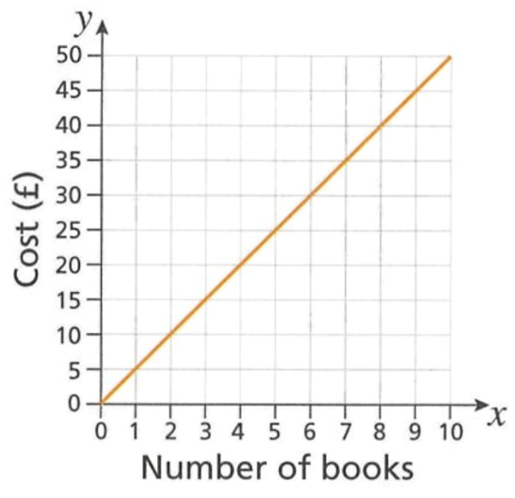
  - Use the graph to find the cost of
    - 7 books
£35
    - 1 book
£5
  - Find the equation of the line $y=kx$.

Gradient is 5. So $y=5x$
  - Interpret the gradient of the line
in the context of the question.

$k=5$ means each book costs £5

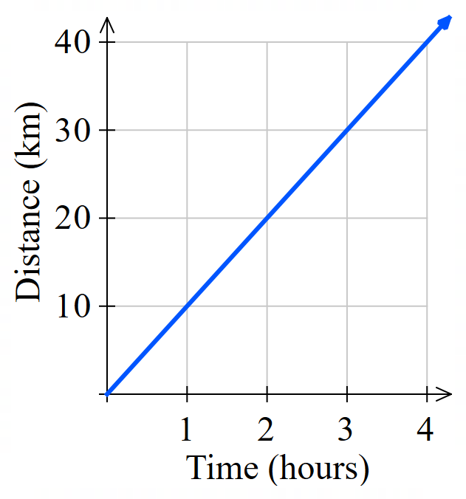
- This graph shows how far a bike travels over 4 hours.
  - Find the gradient of the graph.

10
  - What rate does the gradient represent?

speed in km/h
  - Write an equation relating distance $d$ and time $t$.

$$d=10t$$
  - Use the equation to find:
- The distance travelled in 3.5 hours  35 km | - time required to travel 55 km.  5.5 hrs or 5 hrs 30 min

- Water is poured into an empty tank at a constant rate.
It takes 3 hours to fill the tank with 6000 litres. The graph is shown.
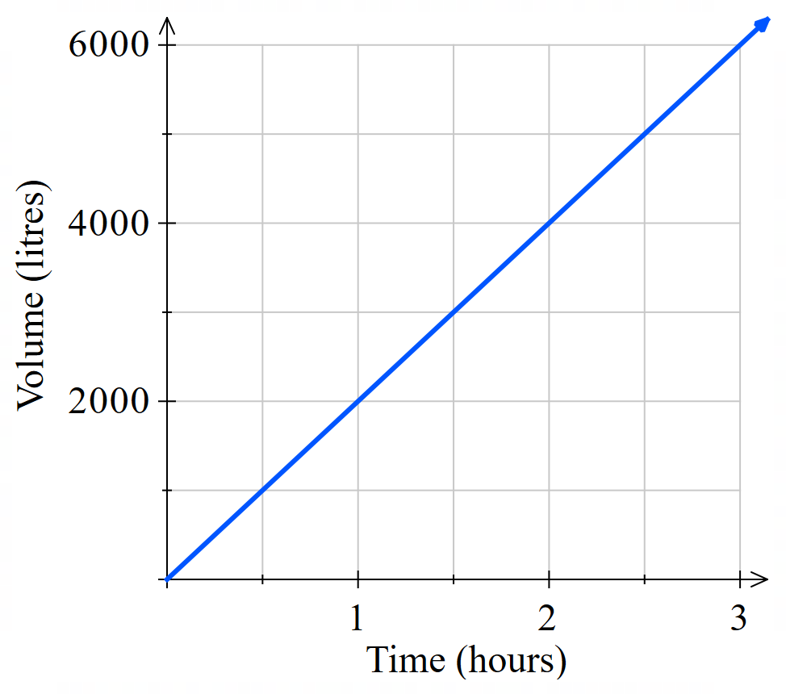
  - Find the gradient.

2000
  - What does the gradient represent in this scenario?

2000 litres per hour
  - Write the equation relating volume $V$ and time $t$.

$$V=2000t$$
  - Use the equation to find:
- volume after 8.5 hours  17000 L | - time to fill 7500 litres  3.75 h

Development
- Here are four graphs showing water flow. For each graph, work out the rate of flow in litres per minute, the volume of water delivered in 30 minutes, and the time it takes to deliver 1000 litres.
Flow rate:  12.5 L/min  Volume delivered in 30 minutes:  360 L  Time to deliver 1000 litres:  83.3 min | 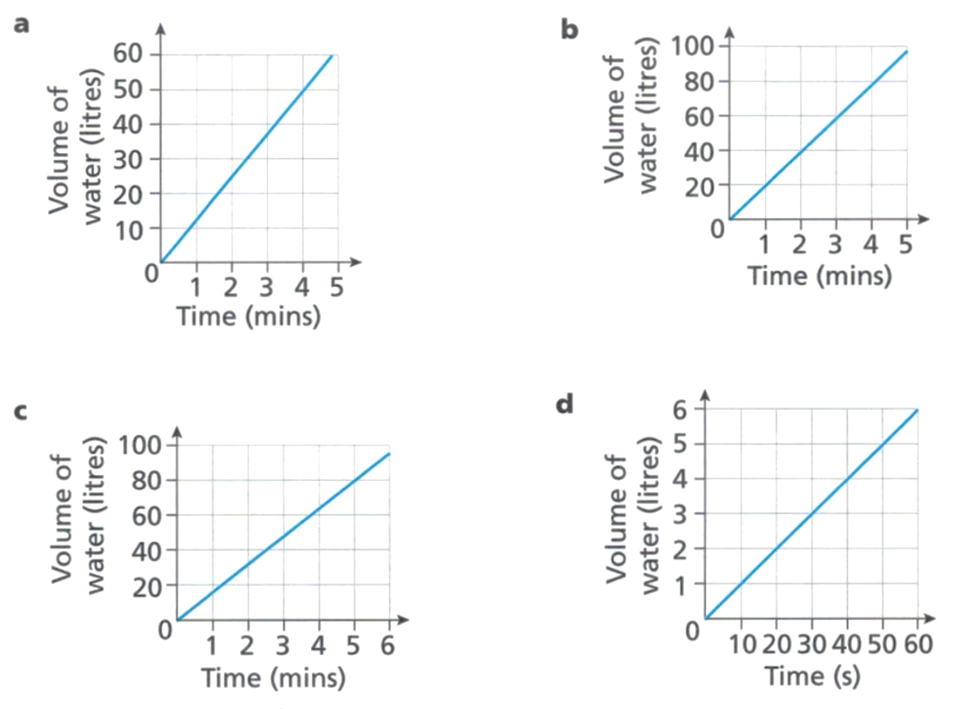  Flow rate:  20 L/min  Volume delivered in 30 minutes:  600 L  Time to deliver 1000 litres:  50 min
Flow rate:  18 L/min  Volume delivered in 30 minutes:  450 L  Time to deliver 1000 litres:  66.7 min | Flow rate:  6 L/min  Volume delivered in 30 minutes:  180 L  Time to deliver 1000 litres:  166.7 min

- A solar-powered car travels 100 km in 4 hours.
  - What is the rate of change of distance over time?
25 km/h
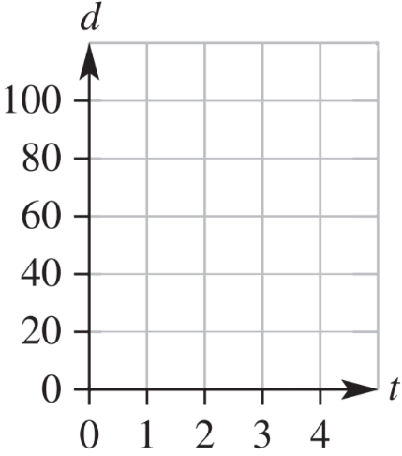
  - Draw a graph of distance ($d$ km) vs time ($t$ hours).
  - Find the:
    - gradient of your graph
25
    - rule for $d$
$$d=25t$$
  - Use your rule to find the:
    - distance after 2.5 hours
62.5 km
    - time to travel 40 km
1.6 h

- The interest, $$I$, earned on a principal of $$P$ for 1 year is given by the formula $I=kP$,
where $k$ is a constant.
  - If an investment of $6000 earns interest of $300, find the value of $k$

$$k=0.05$$
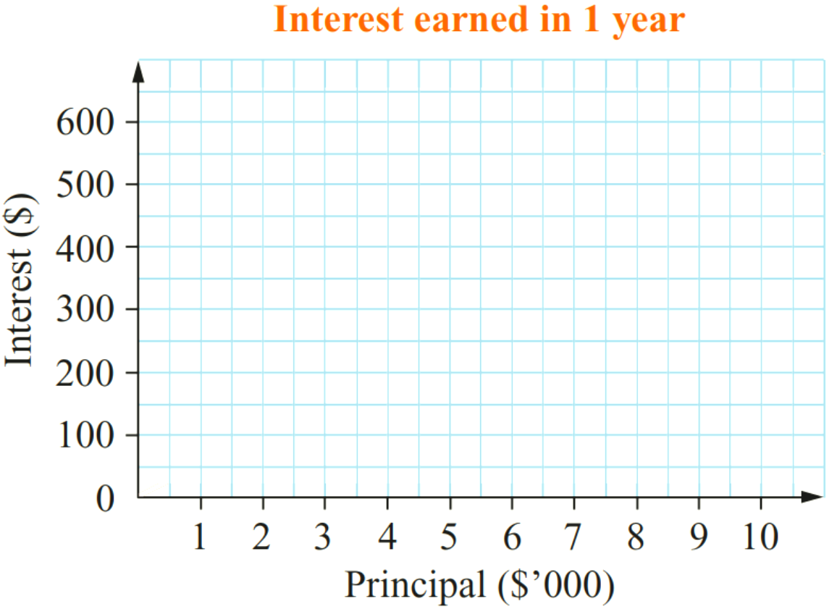
  - Complete the table and draw the graph.
$$P$$ | 2000 | 4000 | 6000 | 8000 | 10000
$$I$$
100, 200, 300, 400, 500
  - Calculate the gradient of the graph.
What is its meaning in this context?
(Hint: think of the simple interest formula)

Gradient is 0.05
This is the annual interest rate, 5%

- The volume $V$ m³ of a prism is related to its height by $V=kh$, where $k$ is a constant.
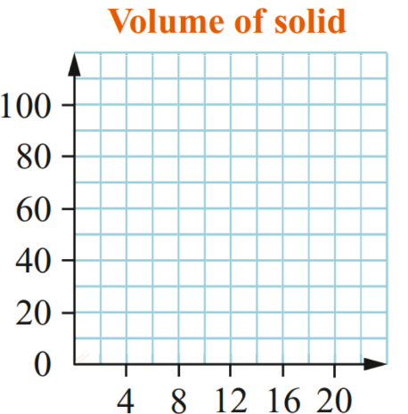
  - Use the information in the table to find the value of $k$
$$h$$ | 4 | 8 | 12 | 16 | 20
$$V$$ |  | 34

17, 34, 51, 68, 85
  - Complete the table using your value of $k$
and graph the relationship.
  - What is the gradient and what is its meaning in this context?
(Hint: think of the volume of a prism formula)

4.25.
This is the cross-sectional area of the prism. $V=Ah$, so $\frac{V}{h}$ $=A$
- Water flows into a tank at a constant rate.
The graph shows how the volume of water in the tank changes with time.
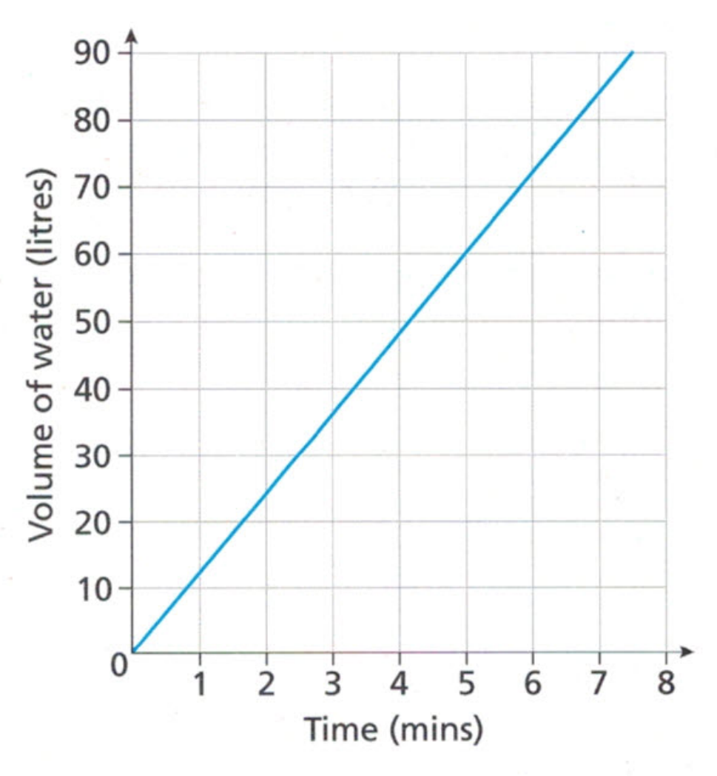
  - Find the rate of flow in litres/min.
Choose two points that you can read clearly.

Using (5,60): 12 L/min
  - How much water will flow into the tank in 1 hour?

720 L
  - The capacity of the tank is 1800 litres.
How long will it take to completely fill the tank
at the rate you found in part a?

150 min

Conversion Graphs

- Unit Conversions
Many unit conversions are an example of direct variation.
The gradient represents the conversion factor.

- Example Apply direct variation in conversion graphs
Consider the linear model:  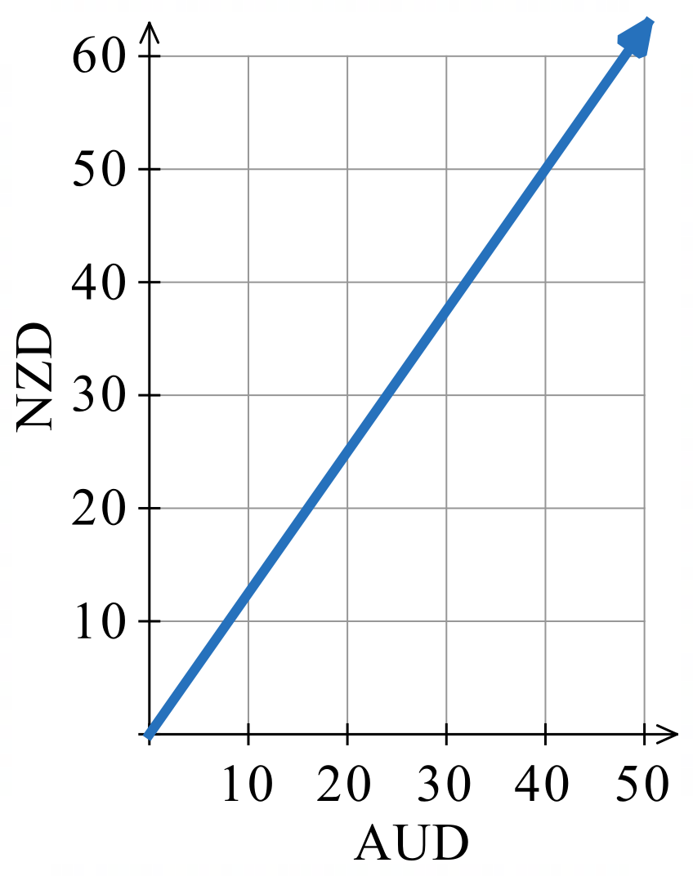 | Convert 40 AUD to NZD.  50 NZD.  Convert 25 NZD to AUD.  20 AUD.  Find the gradient of the line, what is its meaning?  Using (0,0) and (20,25):  $m=$ $\frac{25}{20}$ $=1.25$,  1.25 NZD per AUD  Write an equation relating NZD and AUD.  $y=kx$  $NZD=1.25 AUD$

- Guided Practice
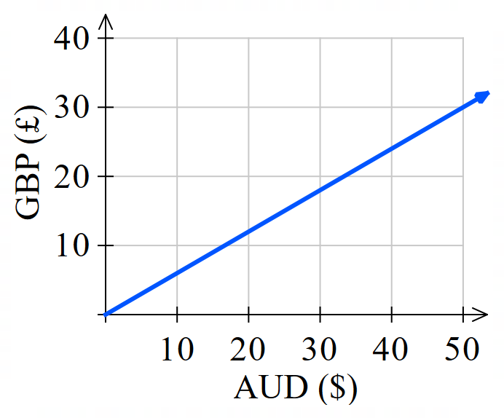
The conversion graph is used to convert Australian dollars to British pounds.
  - Convert 50 AUD to GBP

£30

  - Find the gradient. What is its meaning in this context?

0.6 GBP per AUD
  - Write an equation relating AUD and GBP

$$GBP=0.6 AUD$$
  - Use your equation to find how much AUD you can buy with 20 GBP.

$33.33

Foundation
- Centimetres and inches are directly proportional.
Use the graph to do these conversions:
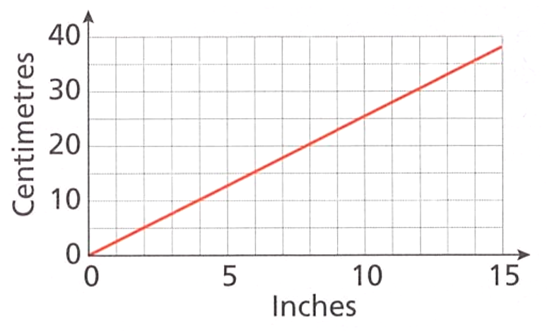
  - 6 inches to cm.
15 cm
  - 20 cm to inches.
8 inches
  - Find the gradient, use the point (10, 25).

2.5
  - What does the gradient represent?
2.5 cm per inch
  - Using your equation, how many inches is 200 cm?
$$C=2.5I$$
$$200=2.5I$$
$I=$ 80 inches

- You can use this graph to convert between gallons and litres.
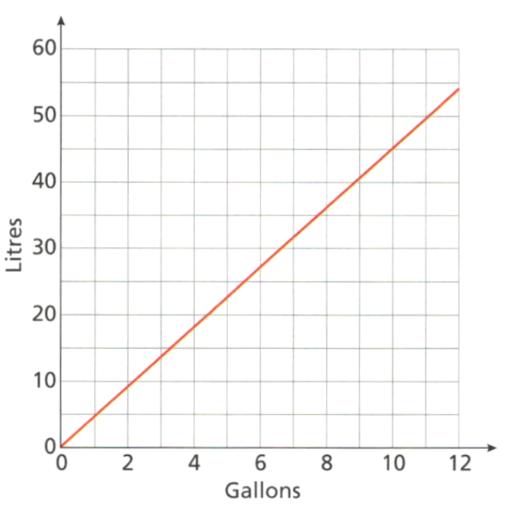
  - Convert 10 gallons to litres.
45 L
  - Convert 30 litres to gallons.
Around 6.6 gal
  - Why might your answer to part b be inaccurate?

The graph is not clear
  - Find the value of $k$ by using the point (10, 45).

$$k=4.5$$
  - Hence use your equation to find the exact number of gallons for 30 litres.

$$L=4.5G$$
$$30=4.5G$$
$G=6.\dot{6}$gallons

Development
- This conversion graph relates weight on Earth $E$ and weight on Mars $M$.
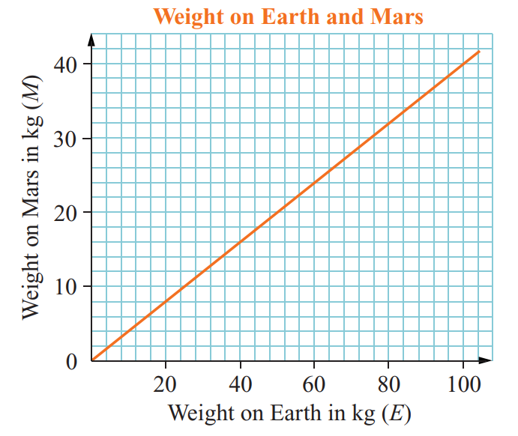
  - Use the point $(100,40)$ to find the value of $k$ and write the equation $M=kE$

$$M=0.4E$$
  - Use the equation to fill in the table below.
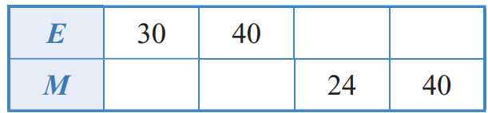

12, 16, 60, 100
- This conversion graph relates miles per hour $M$ and kilometres per hour $K$.
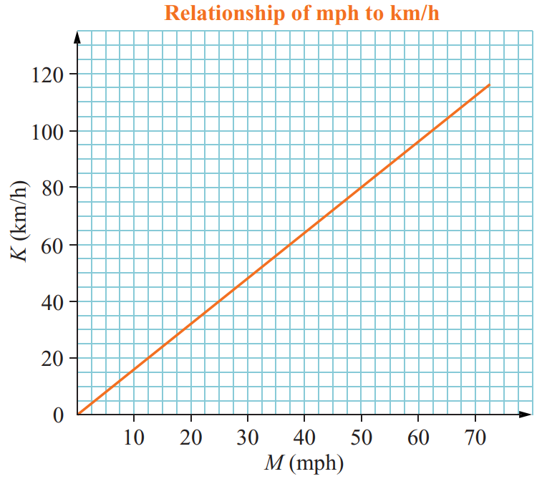
  - Use the point $(62,100)$ to find the value of $k$ and write the equation $K=km$

$$K=\frac{50}{31}m$$
  - Use the equation to fill in the table below.
Round to 1 d.p.
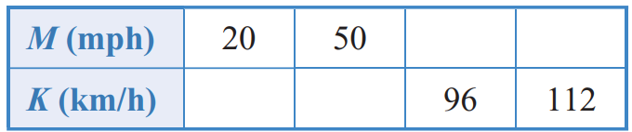

32.3, 80.6, 59.5, 69.4
- The graph shows the conversion between US dollars $, and euros, €.
How many euros is $300 US?
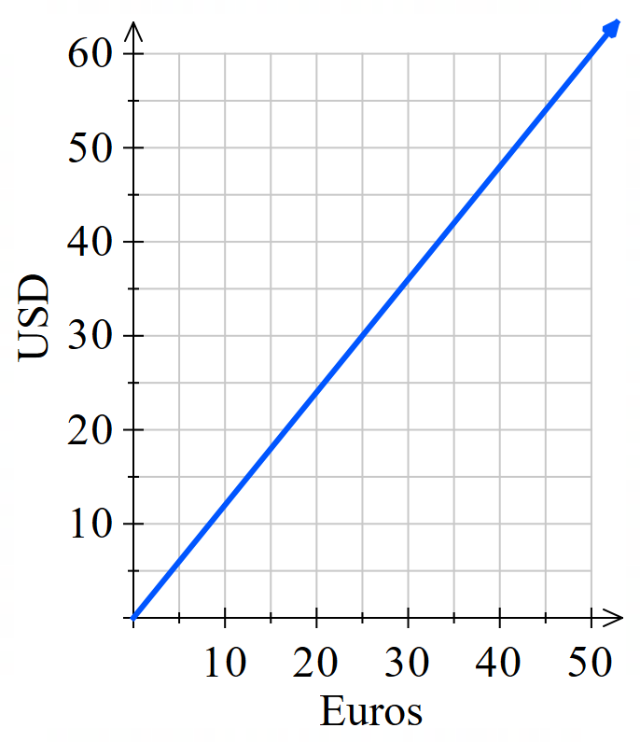

Using (50,60), $k=1.2$
$$D=1.2E$$
$$300=1.2E$$
$E=250$ Euros

Mastery
- 2019 HSC Standard 2 Band 5
The relationship between British pounds $(p)$ and Australian dollars $(d)$ on a particular day is shown in the graph.
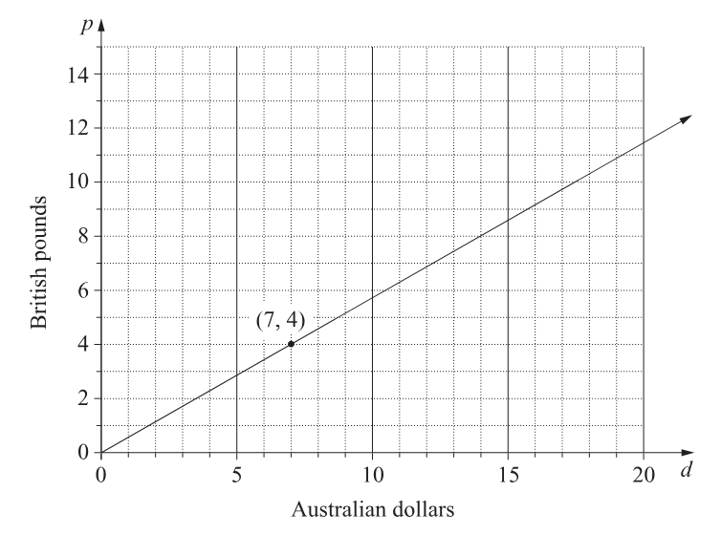
  - Write the direct variation equation relating pounds to dollars in the form $p=md$.
Leave $m$ as a fraction.

Use (0,0) and (7,4)
$$P=\frac{4}{7}d$$
  - The relationship between Japanese yen $(y)$ and Australian dollars $(d)$ on the same day is given by the equation $y=76d$. Convert 93 100 Japanese yen to British pounds

First convert Japanese yen to Australian dollars:
$$93100=76d$$
$$d=1225$$
Now convert Australian dollars to British pounds using the equation from part (a):
$$p=\frac{4}{7}×1225 =700 pounds$$
- Use the two graphs below to find the exchange rate between British pounds and Japanese Yen.
Answer as an equation $JPY=k GBP$.
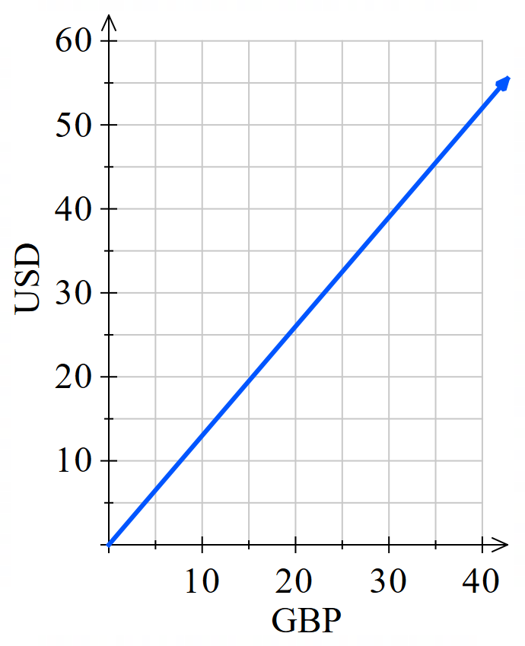
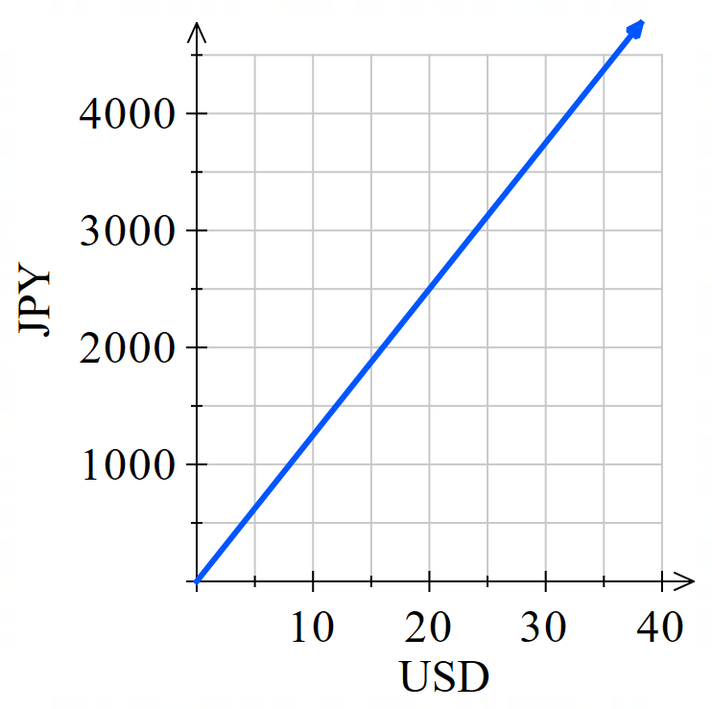

JPY = 150 GBP
- 2007 HSC Standard 2 Band 4
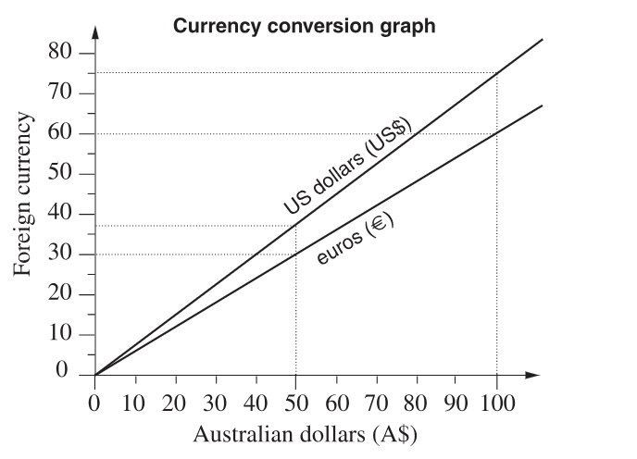
Sandy travels to Europe via the USA. She uses this graph to calculate her currency conversions.

  - After leaving the USA she has US$150 to add to the A$600 that she plans to spend in Europe. She converts all of her money to euros. How many euros does she have to spend in Europe?

From the graph, $100 AUD = 75 USD, so $150 USD = $200 AUD.
So she has $200 + $600 = $800 AUD to spend
Converting to Euros:
From the graph, $100 AUD = 60 EUR
So $800 AUD = 480 EUR

  - If the value of the euro falls in comparison to the Australian dollar, what will be the effect on the gradient of the line used to convert Australian dollars to euros?

If the value of the Euro falls, $1 AUD would buy more Euros, so the gradient would increase; the line would get steeper.

Analysing Inverse Variation with Graphs

- Inverse Variation with Graphs
Two quantities are inversely proportional if:
- An increase in one quantity causes a proportional decrease in the other.
- A decrease in one quantity causes a proportional increase in the other.
The graph of inverse variation is a hyperbola, also called a reciprocal relationship.
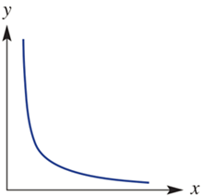
constant of
proportionality
$y=\frac{k}{x}$

- Example Interpret a reciprocal model
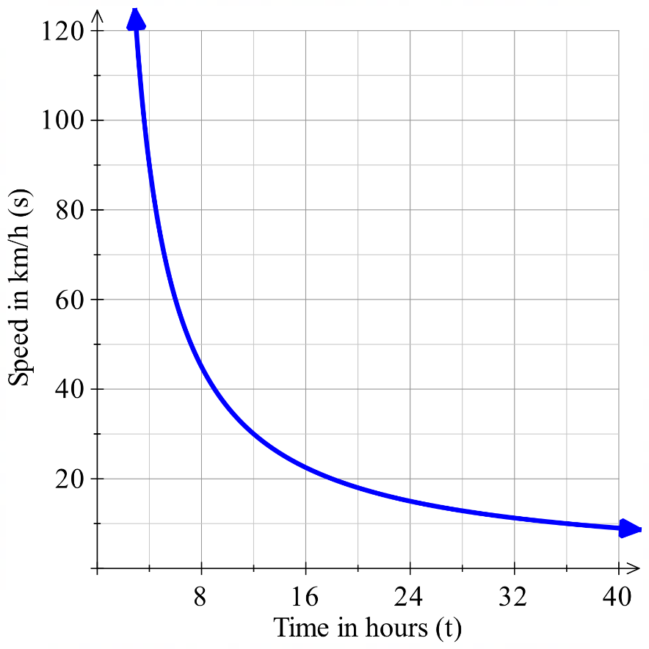
The equation $s=$ $\frac{400}{t}$ can be used to model the average speed needed to travel 400 km in a particular time, where $s$ is speed in km/h and $t$ is time in hours.
What is the average speed required to complete a
400 km trip in 5 hours?
Using graph: $≈$ 80 km/h
Using equation: $s=$ $\frac{400}{5}$ $=80$km/h
How long would it take to complete the trip at 95 km/h?
Using graph: $≈$ 4 hours
Using equation: $95=$ $\frac{400}{t}$
$t=$ $\frac{400}{95}$ $≈4.21$ hours
$=$ 4 hours 13 minutes.
Why is it impossible for $t=0$? Explain by referring to the context of the model.
We would have $s=\frac{}{}$, which is u…d…………… In the context of the model, we cannot travel ………… km in ………… hours, this would require …………… speed.
Why is it impossible for $s=0$? Explain by referring to the context of the model.
We would have $0=\frac{400}{t}$, which is impossible. In the context of the model, it is not possible to travel …………… km at ………… speed, it would require ……………… time.
Why did we not consider the other half of the hyperbola?
………………… cannot be negative.

- Guided Practice
Paul rents a guesthouse from the landlord for $720 per week.
To save money, he has other people stay and divides the expense equally.
The equation that models this situation is $C=$ $\frac{720}{n}$, where $C$ is cost in dollars per person and $n$ is the number of people staying per week.
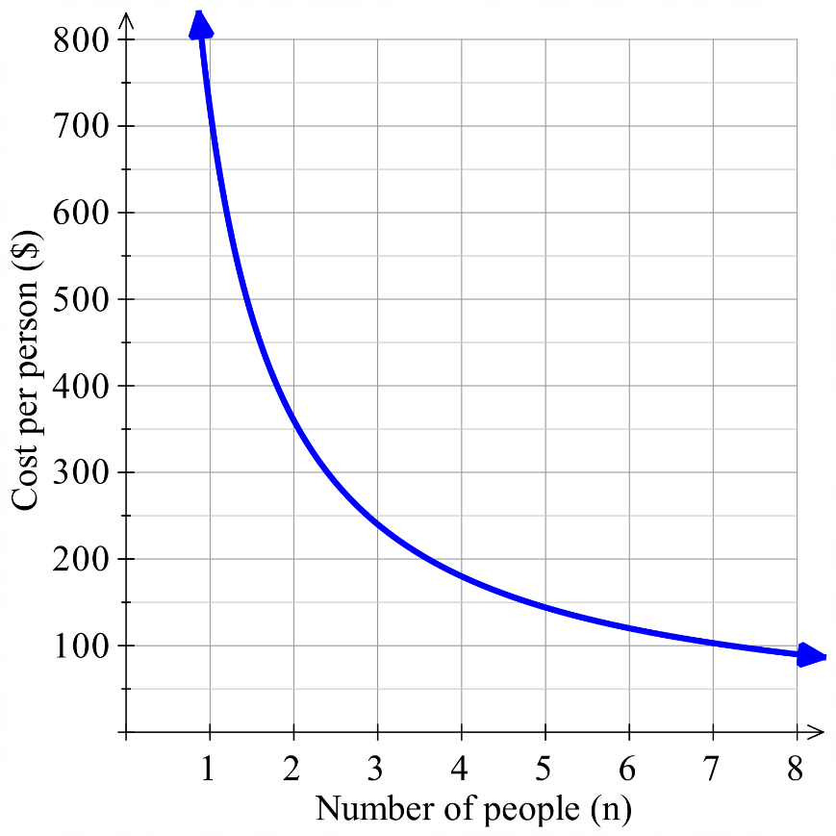
  - What is the cost per person when 3 people
are staying?

$240
  - How many people are needed so cost per person
is $144?

5 people
  - What are the limitations of this model? (hint: can $n$ be a fraction?)

$n≥1$ and must be a whole number.
The equation $s=$ $\frac{360}{t}$ can be used to model the average speed necessary to travel 360 km in a particular time, where $t$ is the time in hours and $s$ is the speed in kilometres per hour.
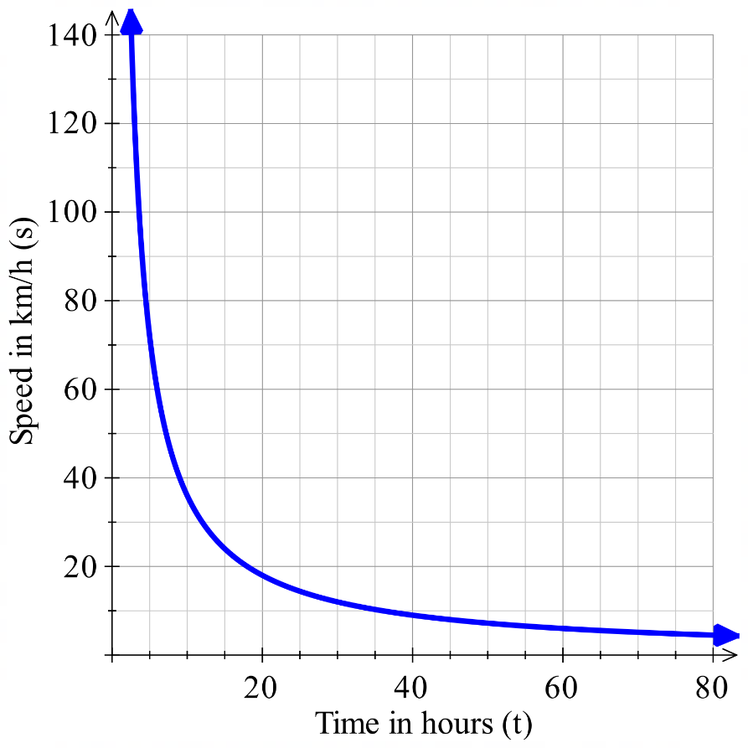
  - What does the 360 represent?

Total distance
  - What average speed is required to complete the 360 km trip in 12 hours?

30 km/h
  - How long would it take to complete the trip at 75 km/h?

4.8 h

Foundation
- The time taken in hours ($t$) for a road trip, at an average speed ($s$), in km/h, is given by $t=\frac{1500}{s}$
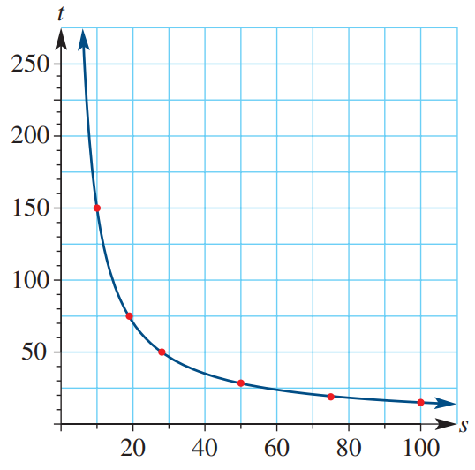
  - How long would the road trip take at 50 km/h?
30 hours
  - How long would the road trip take at 75 km/h?
20 hours
  - What is the speed required to complete the road trip in 25 hours?

60 km/h
  - Why would it be impossible to complete the road trip in 5 hours?

You would need to travel 300 km/h, which is too fast for a road trip.
- The total cost $(C)$ of hiring a yacht depends on the number of people $(n)$ sharing the total cost. The equation $C=\frac{320}{n}$ is used to model this situation.
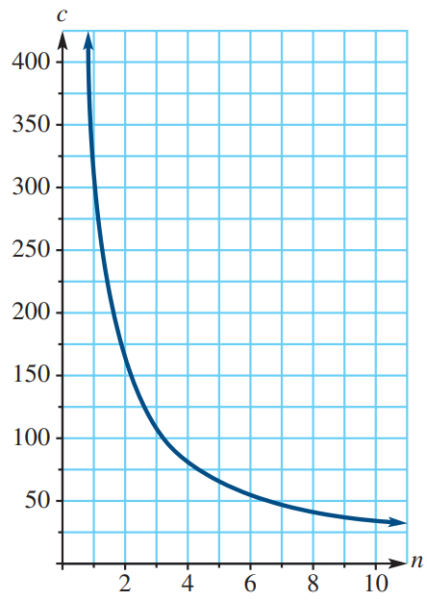
  - What is the cost of hiring the yacht for one person?

$320
  - What is the cost per person of hiring the yacht if 8 people share the total cost?

$40
  - How many people are required to share the cost of hiring a yacht for $80?

4 people
  - Is it possible for the cost per person to be $1?

Yes, if 320 people are sharing the cost (it’s unlikely).

- The time taken ($t$ in hours) to dig a hole is dependent on the number of people ($n$) digging the hole. This relationship is modelled using the formula $t=$ $\frac{6}{n}$
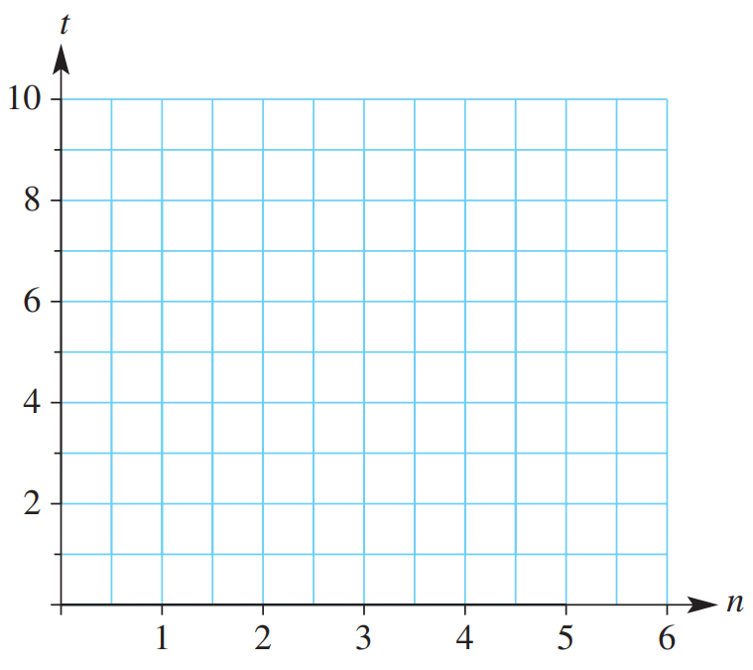
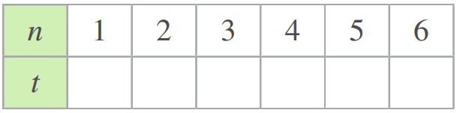
  - Complete the table of values and sketch the graph.

  - How long does it take one person to dig a hole?
6 hours
  - How long does it take 3 people to dig a hole?
2 hours
  - How long does it take 6 people to dig a hole?
1 hour
  - How many people could dig the hole in two hours?
3 people
  - How many people could dig the hole in 30 minutes?
12 people

- The maximum number of people ($n$ in 1000’s) attending an outdoor concert is dependent on the area (A in m²) allowed per person. The reciprocal equation $n=\frac{1.2}{A}$ models this situation.
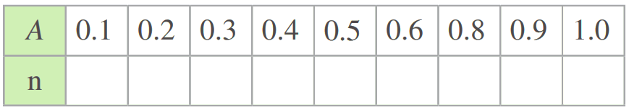
  - Complete the table of values and sketch the graph.

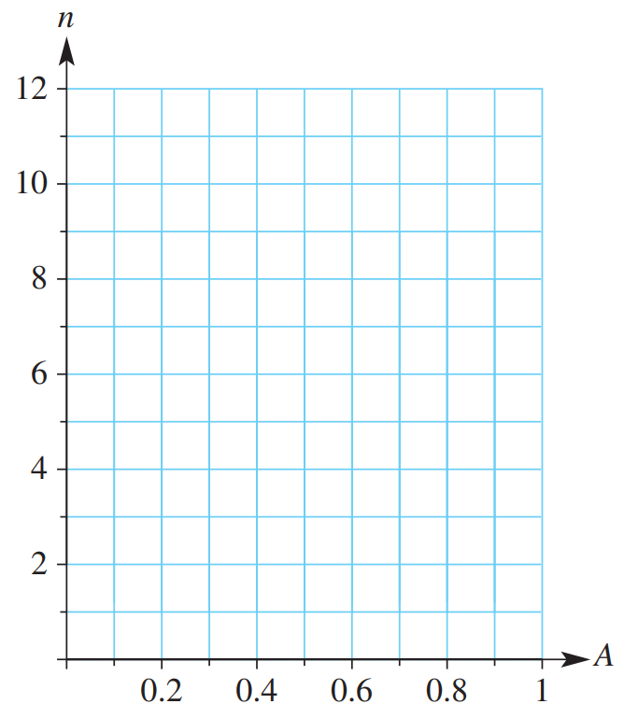
  - How many people can attend if the area
allowed per person is 0.5 m²?

2400
  - How many people can attend if the area
allowed per person is 0.25 m²?

4800
  - What is the area allowed per person if the
maximum number of people attending the
concert is 2000?
0.6 m²
  - Explain why it’s impossible for 12 000 people to attend the concert.
Each person would have 0.1 m², which is not enough to fit a person

Development
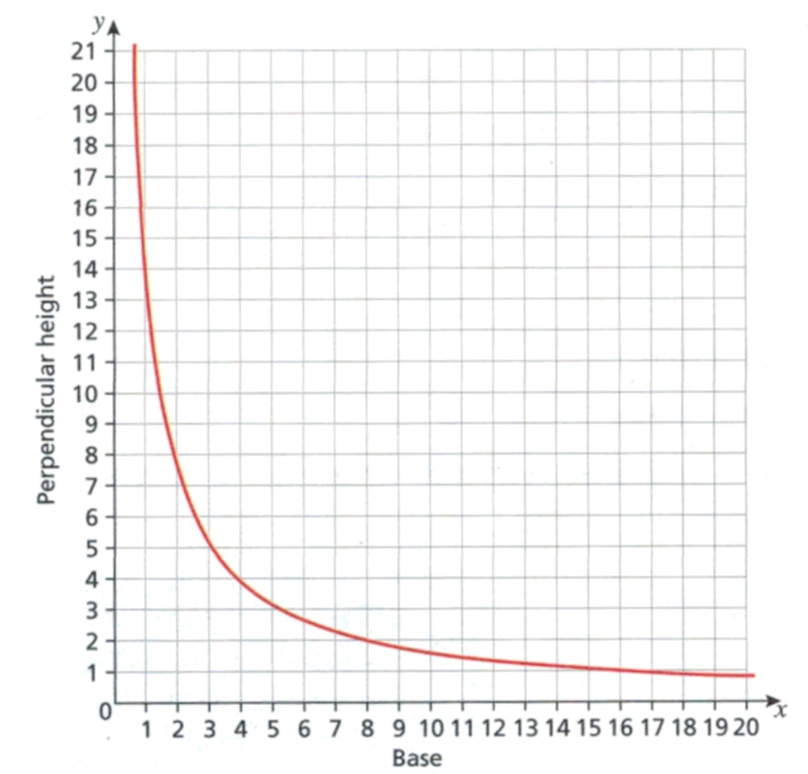
- The graph shows the relationship between the base length and perpendicular height of a parallelogram with area 16 cm².
  - Use the graph to find
    - the height of a parallelogram with base length 8 cm
2 cm
    - the height of a parallelogram with base length 10 cm
1.6 cm
    - the base length of a parallelogram with height 6 cm
$≈2.\dot{6}$ cm
  - Explain why the equation of the graph is given by $xy=16$

Area of a parallelogram is $A=bh=16$, so $xy=16$
- The graph below shows Boyle's law.
This is an inversely proportional relationship between the pressure and volume of a gas.
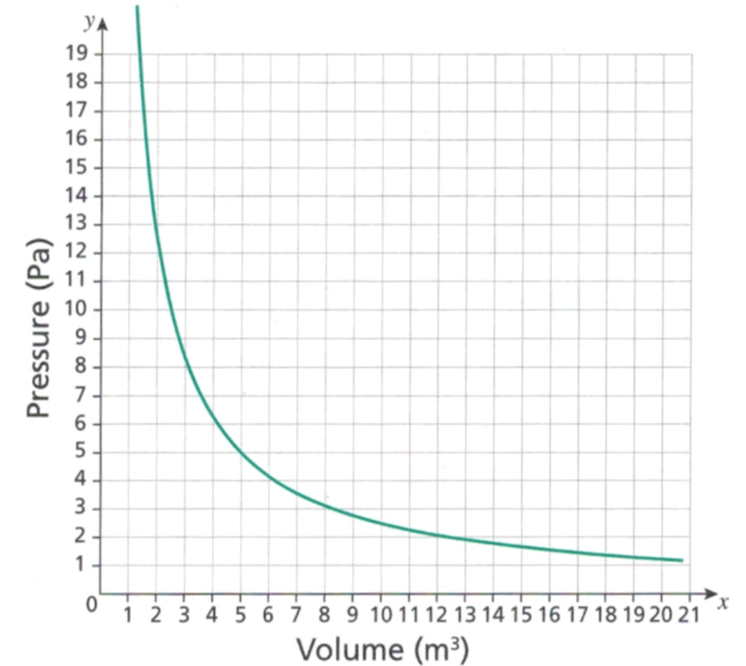
  - Use the graph to find
    - the volume when the pressure is 15 Pa

$≈1.6$ m³
    - the pressure when the volume is 4 m³.

$≈6.25$ Pa
  - Write the equation of the graph in the from $xy=k$, where $k$ is the constant of proportionality.

$$xy=24$$

- The diameter of a balloon $D$ varies inversely with the thickness of the rubber $x$.
The diameter of the balloon is 80 mm when the rubber is 2 mm thick.
  - Using $y=$ $\frac{k}{x}$ , find the constant of variation $k$.

160
  - Hence write an equation relating diameter $D$ and thickness $x$.

$$D=\frac{160}{x}$$
  - Find the diameter when the thickness is 0.8 mm.

200 mm
  - Find the thickness correct to one decimal place when the diameter of 115.3 mm.

1.4 mm
  - Sketch the graph of this information.
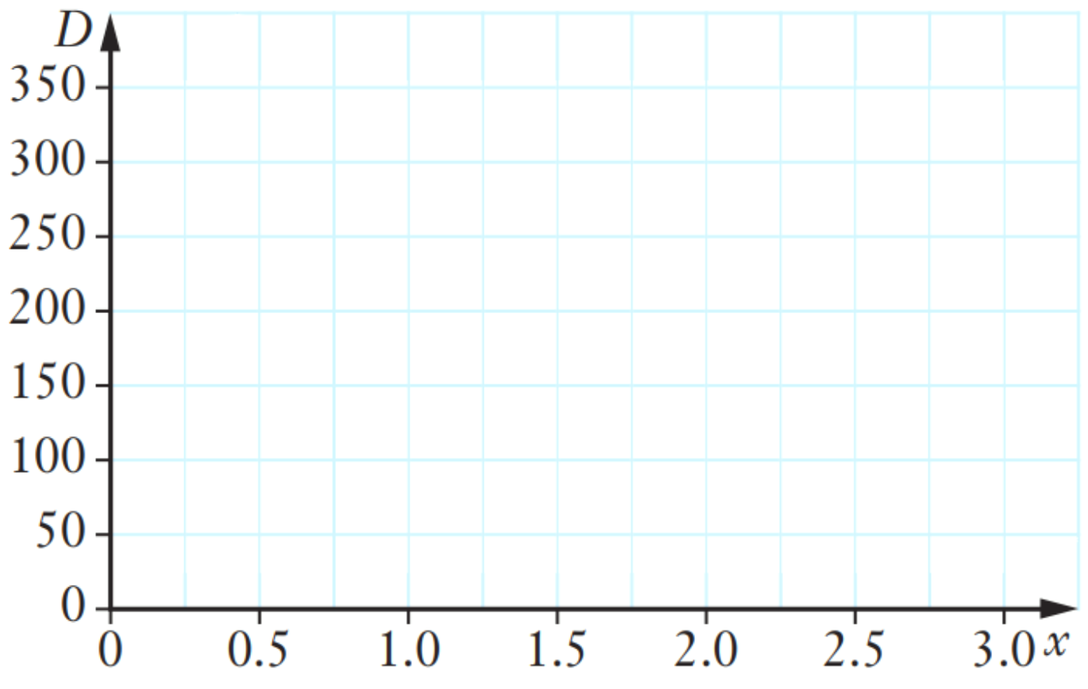

- The number of boxes a factory produces is inversely proportional to the cost to produce each box.
When 128 boxes are produced, it costs $2 per box.
Find an equation relating cost $c$ and boxes $n$ then sketch the graph.
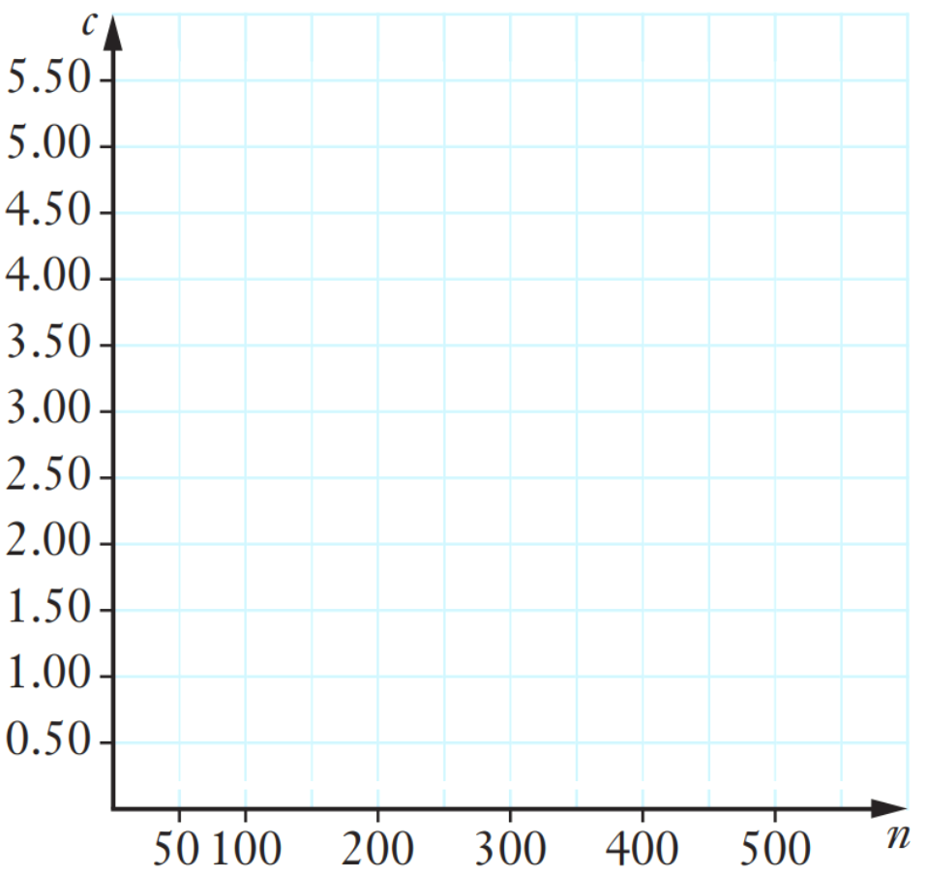

$$c=\frac{256}{n}$$
- 2019 HSC Standard 2 Band 4
The time taken for a car to travel between two towns at a constant speed varies inversely with its speed.
It takes 1.5 hours for the car to travel between the two towns at a constant speed of 80 km/h
  - Calculate the distance between the two towns.

120 km
  - By first plotting four points, draw the curve that shows the time taken to travel between the two towns at different constant speeds.
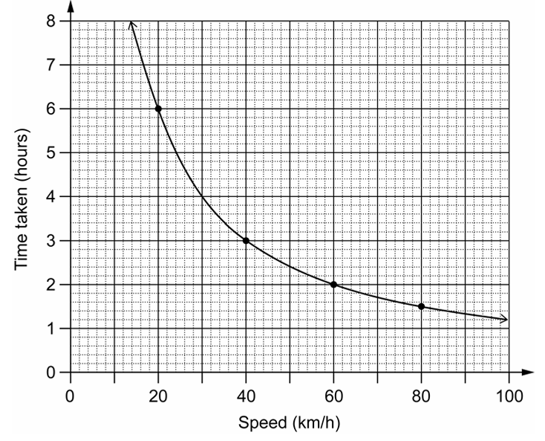
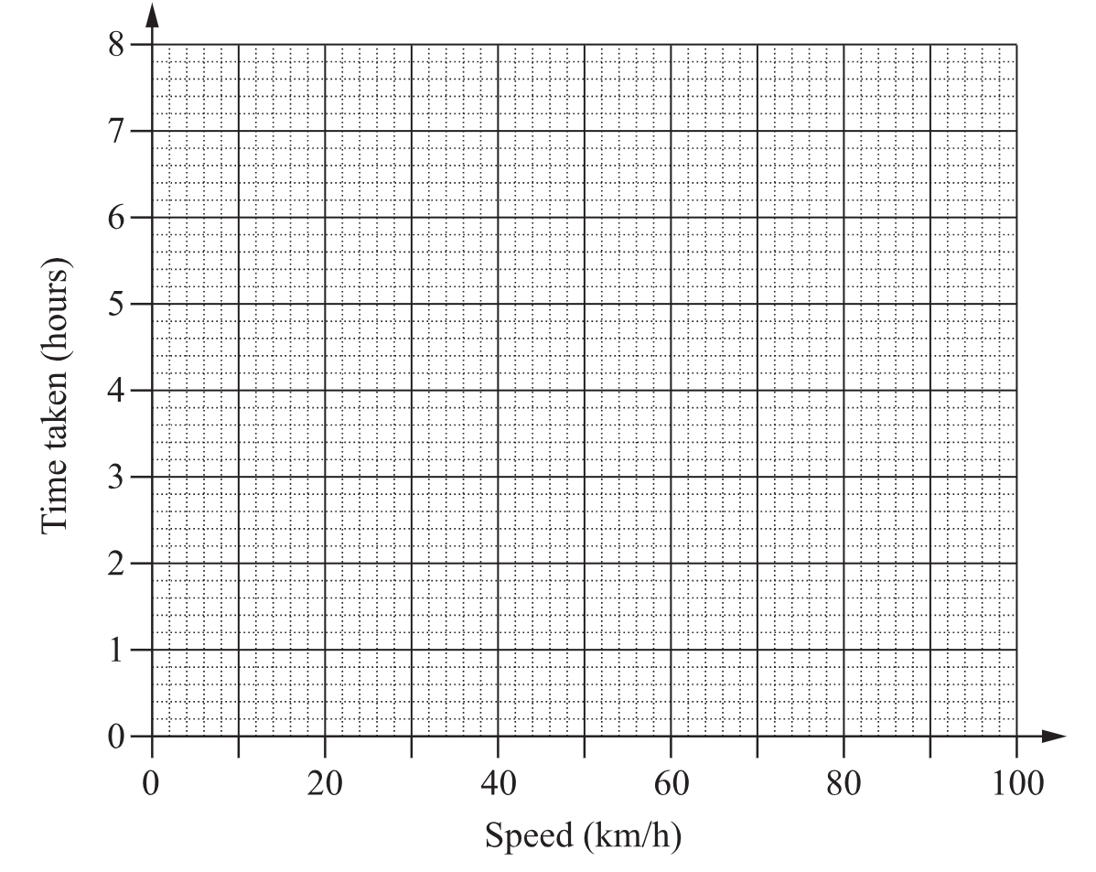

Mastery
- 2022 HSC Standard 2 Band 5
A student believes that the time it takes for an ice cube to melt ($M$ minutes) varies inversely with the room temperature $T °C$. The student observes that at a room temperature of $15 °$C it takes 12 minutes for an ice cube to melt.
  - Find the equation relating $M$ and $T$.

$$M=\frac{k}{T}$$
$$12=\frac{k}{15}$$
$$k=180$$
$$M=\frac{180}{T}$$
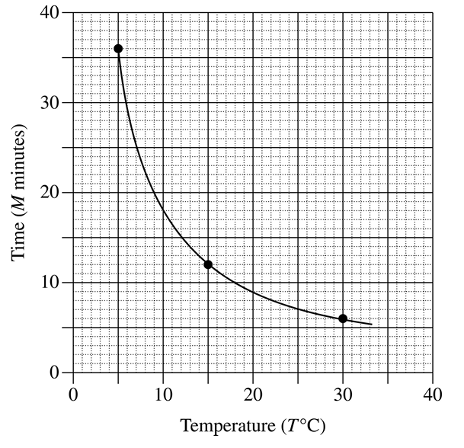
  - Using the table, graph the temperature vs time between $T=5°C$ and $T=30°C$
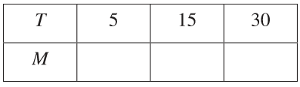
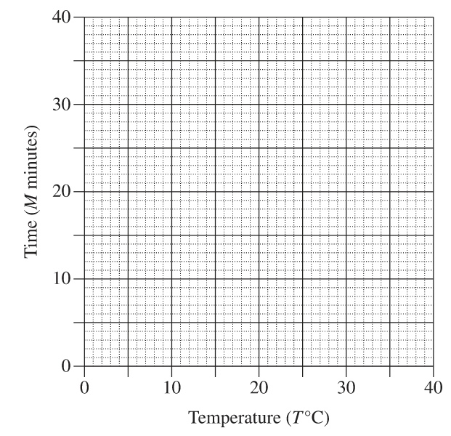

36, 12, 6

- 2018 HSC Standard 2 Band 5
When people walk in snow, the depth ($D$ cm) of each footprint depends on both the area ($A$ cm²) of the shoe sole and the weight of the person. The graph shows the relationship between the area of the shoe sole and the depth of the footprint for a group of people of the same weight.
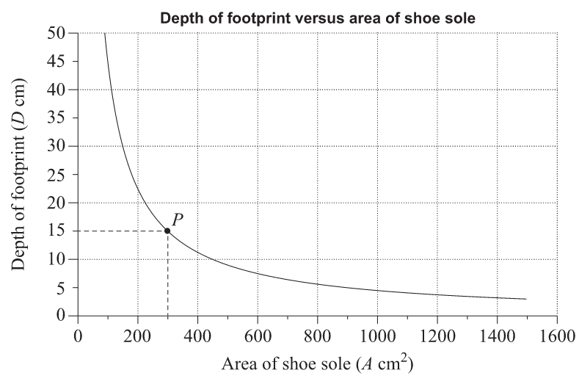

  - The graph is a hyperbola because $D$ is inversely proportional to $A$.
Find the equation relating $D$ and $A$.

$$D=\frac{k}{A}$$
$$15=\frac{k}{300}$$
$$k=4500$$
$$D=\frac{4500}{A}$$
  - A man from this group walks in snow and the depth of his footprint is 4 cm.
Use your equation to calculate the exact area of his shoe sole.

Let $D=4$
$$4=\frac{4500}{A}$$
$A=$ 1125 cm²

Rates of Non-Linear Graphs

- Interpret Graphs of changing rate
Consider the two graphs below.
Constant Speed: a car travelling at a constant speed on a highway.
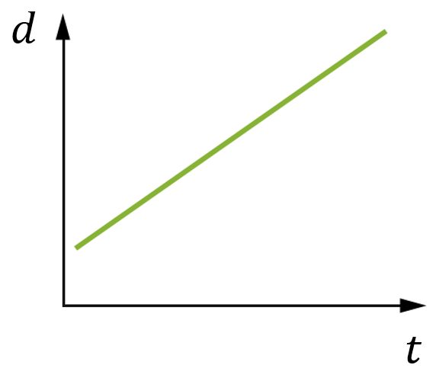
The gradient of the graph represents the …………….
The speed is ………………, so the gradient stays the same.
This creates a ………………-line graph.

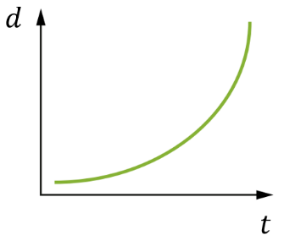
Variable Speed: a car speeding up from a traffic light.
The gradient of the graph represents the speed.
The car starts off ……………, then ………………….
The gradient starts off …………, then gets …………….
This creates a ……………… graph.
A graph can show how any quantity changes over time.
When a quantity increases at a …………… rate, the gradient stays the same, producing a straight-line graph.
When the rate of change varies, the gradient ……………… producing a curved graph.
The gradient of a graph represents the ……………… of change of the quantity at any given moment.

- Rates of Non-Linear Graphs
- A linear graph has a constant gradient - the rate stays the same.
- In a non-linear graph, the gradient changes.
Increasing at a constant rate  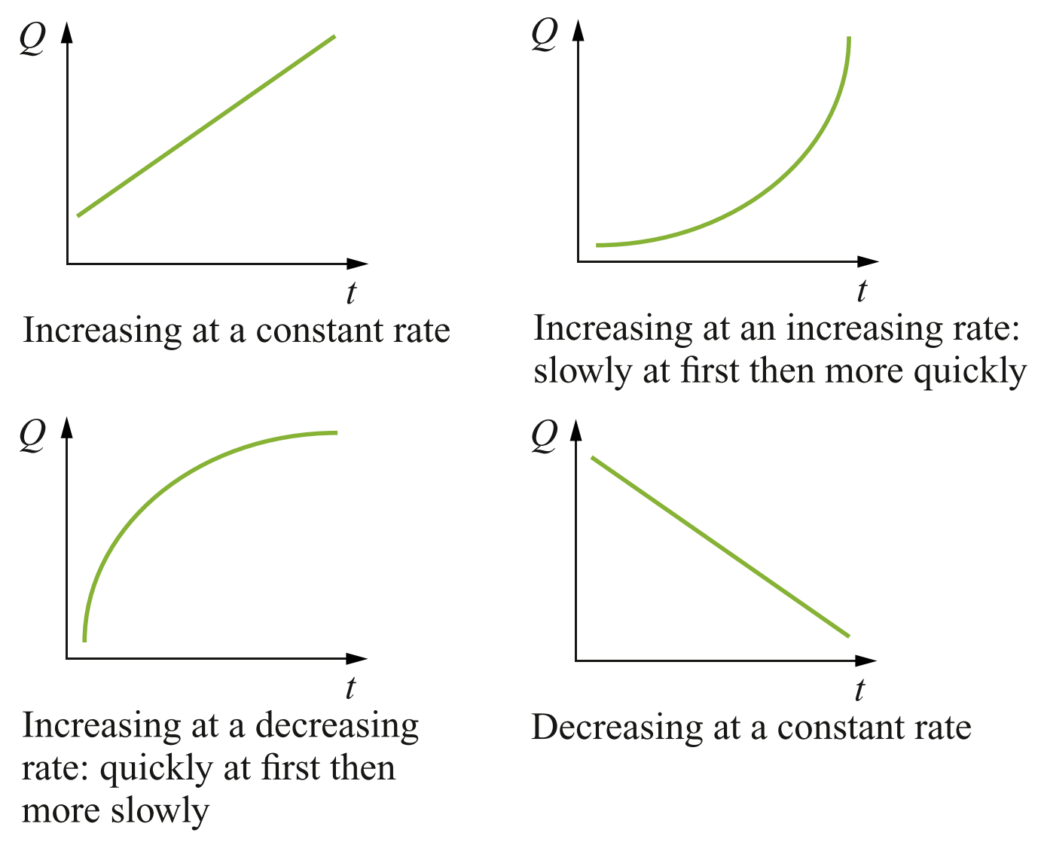 |  | Decreasing at a constant rate
Increasing at an  Increasing rate | Increasing at a  Decreasing rate | Decreasing at a  Decreasing rate  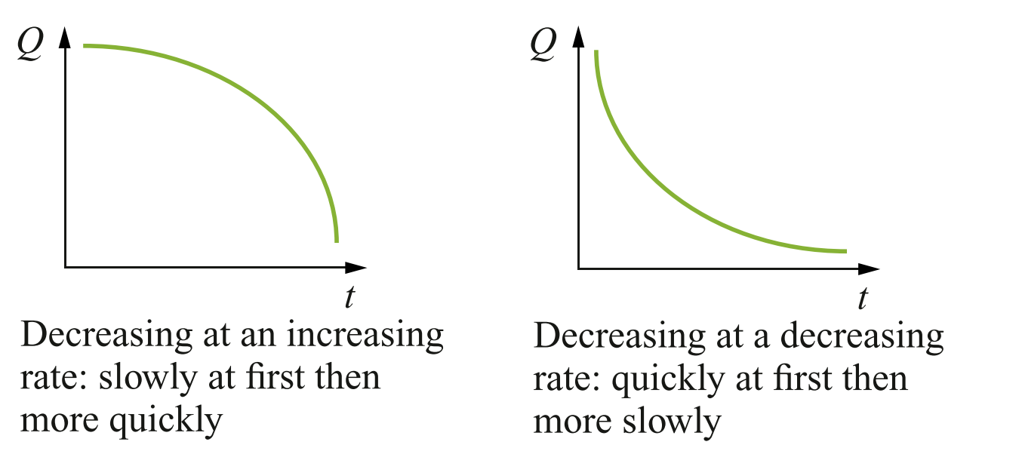 |  | Decreasing at an  Increasing rate
- Identify rate of change of a curve
Match the following descriptions to the graph.
A Distance from home is increasing at a decreasing rate.
B Distance from home is increasing at an increasing rate.
C Distance from home is decreasing at an increasing rate.
D Distance from home is decreasing at a decreasing rate.
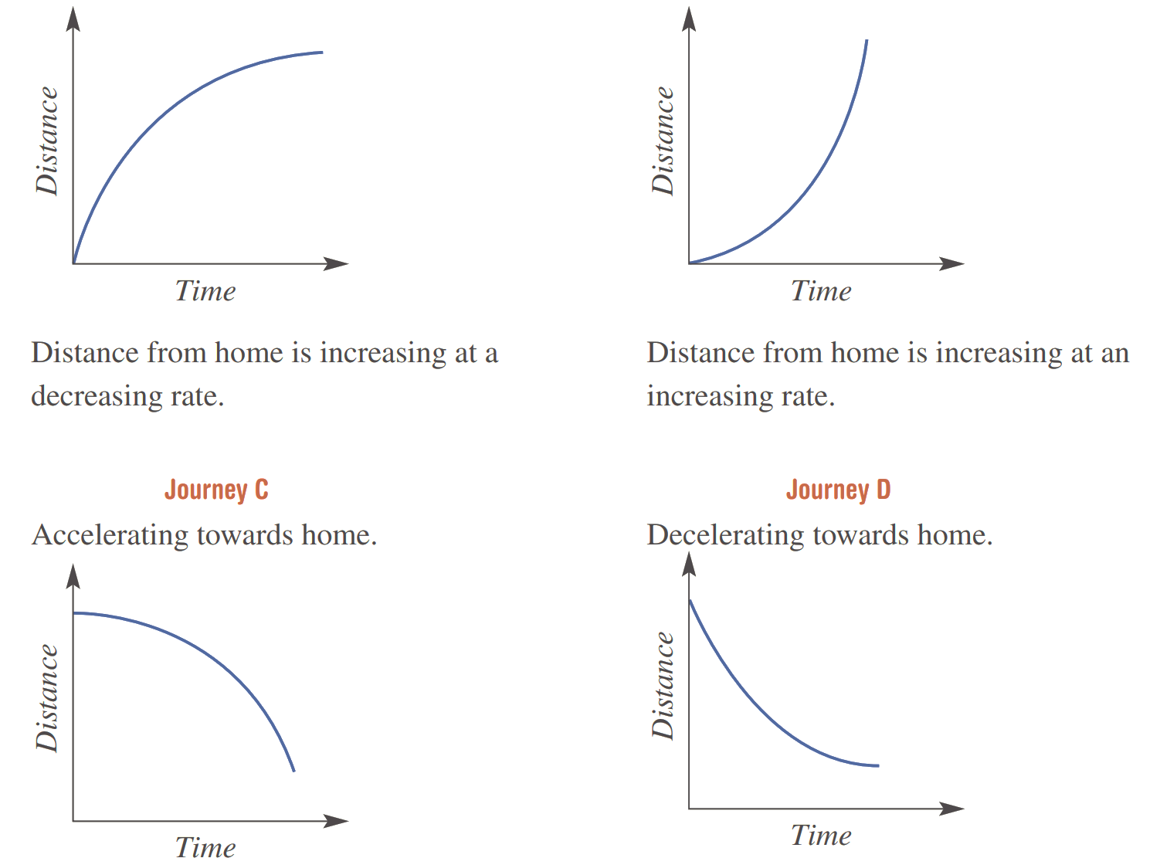

The graph shows a distance-time graph,  Label the parts of the curve where the object is:  - Slowing down (decelerating)  - Stopped  - Travelling with constant speed |  |  | 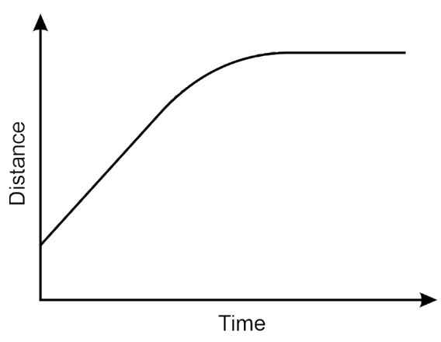
The graph shows a distance-time graph,  Label the parts of the curve where the object is:  - Slowing down (decelerating)  - Speeding up (accelerating)  - Stopped  - Travelling with constant speed |  |  | 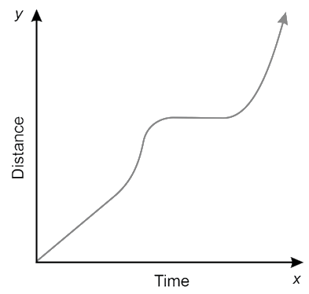

- Identify Rate of change from graphs
These distance-time graphs show various journeys, each with distance measured from home, where $d=0$. For each graph, select an appropriate description from the list.
Graph | Distance | Gradient | Speed
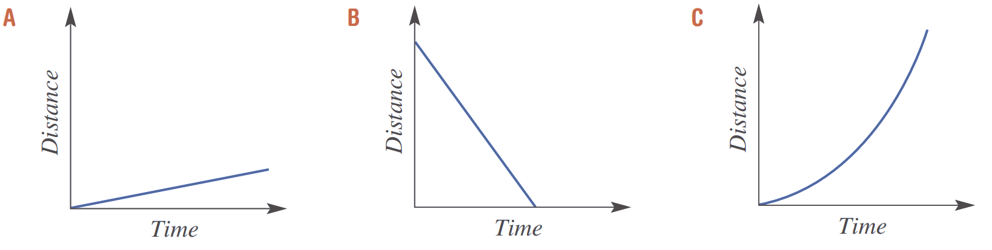 | - Increasing  - Decreasing  - Not changing | - Positive  - Negative  - Zero | - Increasing  - Decreasing  - Constant  - Zero
 | - Increasing  - Decreasing  - Not changing | - Positive  - Negative  - Zero | - Increasing  - Decreasing  - Constant  - Zero
 | - Increasing  - Decreasing  - Not changing | - Positive  - Negative  - Zero | - Increasing  - Decreasing  - Constant  - Zero speed
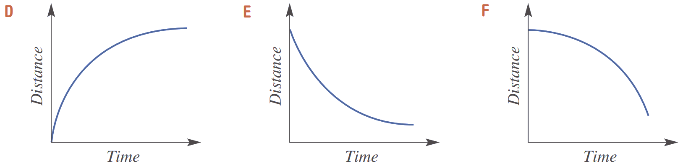 | - Increasing  - Decreasing  - Not changing | - Positive  - Negative  - Zero | - Increasing  - Decreasing  - Constant  - Zero
 | - Increasing  - Decreasing  - Not changing | - Positive  - Negative  - Zero | - Increasing  - Decreasing  - Constant  - Zero
 | - Increasing  - Decreasing  - Not changing | - Positive  - Negative  - Zero | - Increasing  - Decreasing  - Constant  - Zero
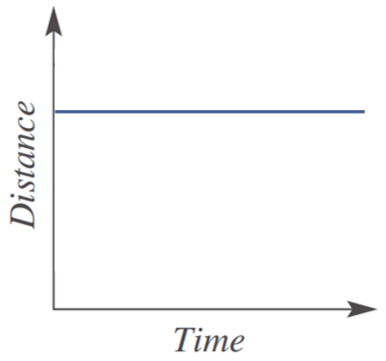 | - Increasing  - Decreasing  - Not changing | - Positive  - Negative  - Zero | - Increasing  - Decreasing  - Constant  - Zero

Foundation
- Each graph below is part of a distance–time graph.
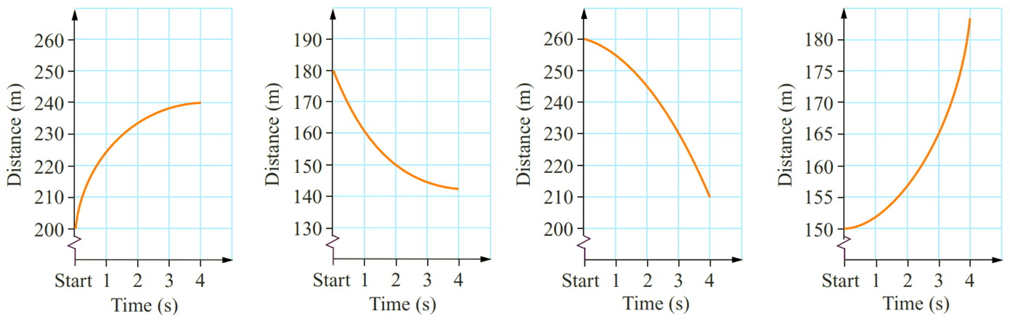 |  | 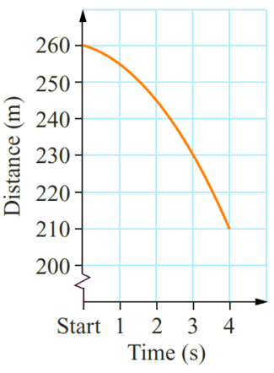
  - In the first second of observation, how far did each car travel?
25 | 20 | 5 | 2
  - In the second second of observation, how far did each car travel?
8 | 10 | 10 | 5
  - In the third second of observation, how far did each car travel?
5 | 5 | 15 | 8
  - In the fourth second of observation, how far did each car travel?
2 | 3 | 20 | 18
  - Describe how distance is changing over this four second period, using the phrase “increasing/decreasing at an increasing/decreasing rate”
Distance increases at a decreasing rate | Distance decreases at a decreasing rate | Distance decreases at an increasing rate | Distance increases at an increasing rate
  - How does the steepness of a line relate to how quickly distance is changing?

The steeper the curve at a point on it the more quickly distance is changing at that time. (i.e. the speed is greater)

- Match each of the statements below to one of the distance–time graphs.
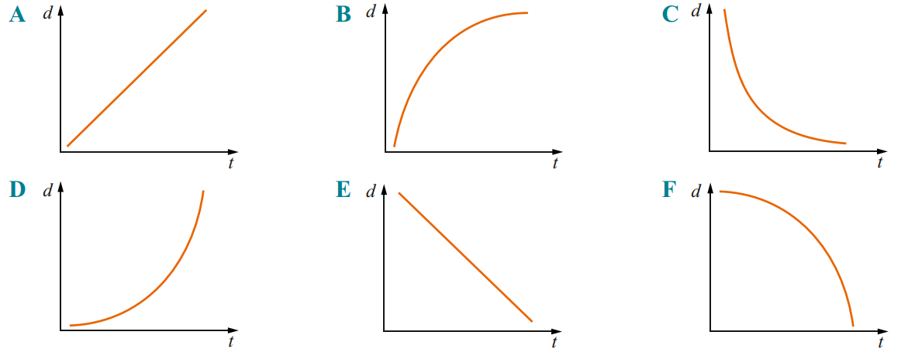

  - Distance increases slowly at first and then more quickly. ……………
D
  - Distance increases quickly at first and then more slowly. ……………
B
  - Distance increases at a constant rate. ……………
A
  - Distance decreases slowly at first and then more quickly. ……………
F
  - Distance decreases quickly at first and then more slowly. ……………
C
  - Distance decreases at a constant rate. ……………
E
- For each graph, complete the sentence by supplying the words “increasing” or “decreasing”.
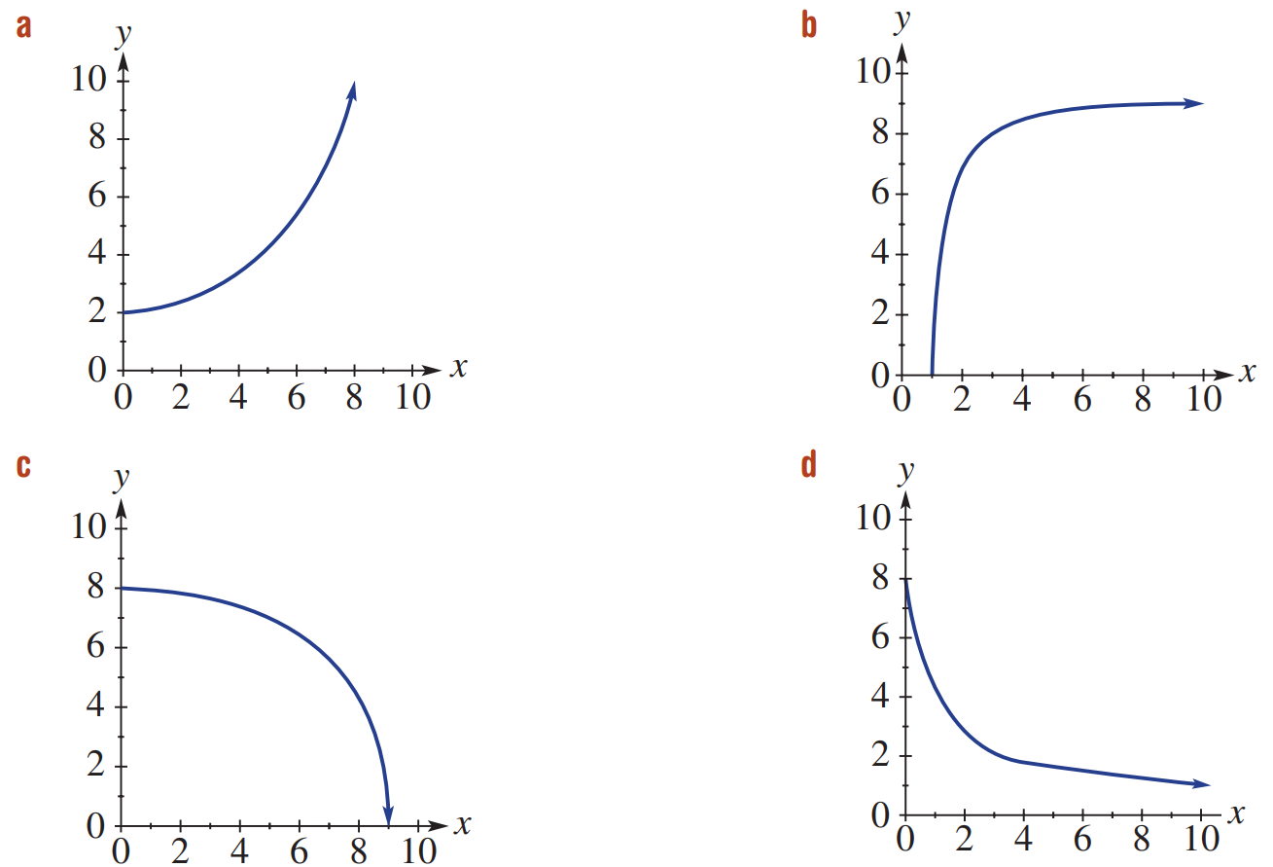  $y$ is ………………… at a ………………… rate.  Increasing, increasing | $y$ is ………………… at a ………………… rate.  Increasing, decreasing
$y$ is ………………… at a ………………… rate.  Decreasing, increasing | $y$ is ………………… at a ………………… rate.  Decreasing, decreasing

Development
- For each graph, select an appropriate description from the list given.
Graph | Distance | Gradient | Speed
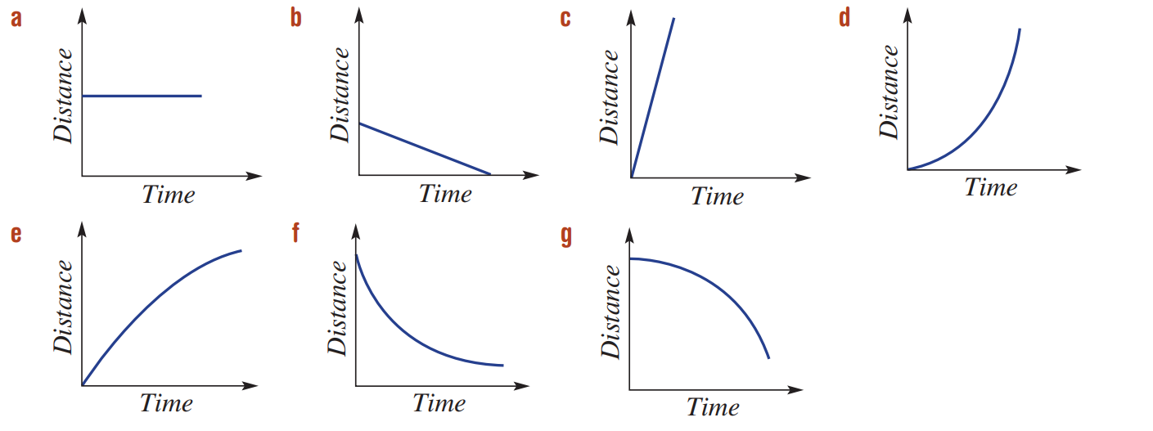 | - Increasing  - Decreasing  - Not changing  Not changing | - Positive  - Negative  - Zero  zero | - Increasing  - Decreasing  - Constant  - Zero  Zero, constant
 | - Increasing  - Decreasing  - Not changing  decreasing | - Positive  - Negative  - Zero  negative | - Increasing  - Decreasing  - Constant  - Zero  constant
 | - Increasing  - Decreasing  - Not changing  increasing | - Positive  - Negative  - Zero  positive | - Increasing  - Decreasing  - Constant  - Zero  increasing
 | - Increasing  - Decreasing  - Not changing  increasing | - Positive  - Negative  - Zero  positive | - Increasing  - Decreasing  - Constant  - Zero  decreasing
 | - Increasing  - Decreasing  - Not changing  decreasing | - Positive  - Negative  - Zero  negative | - Increasing  - Decreasing  - Constant  - Zero  decreasing
 | - Increasing  - Decreasing  - Not changing  decreasing | - Positive  - Negative  - Zero  negative | - Increasing  - Decreasing  - Constant  - Zero  increasing

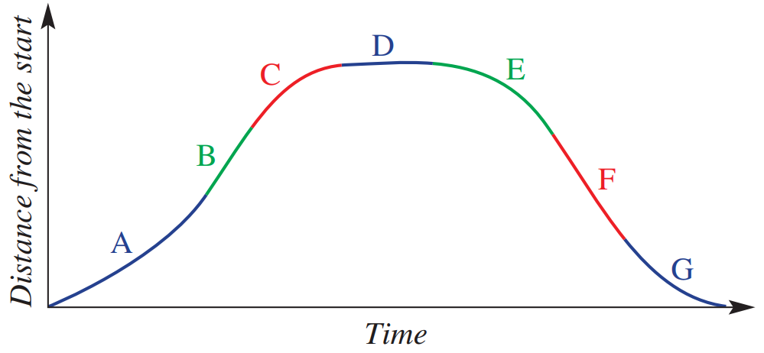
- Select the correct description for the gradient and speed of each segment of this graph.
The rate of change of distance with respect to time is the gradient.

 | Distance | Gradient | Speed
 | - Increasing  - Decreasing  - Not changing  increasing | - Positive  - Negative  - Zero  positive | - Increasing  - Decreasing  - Constant  - Zero  increasing
 | - Increasing  - Decreasing  - Not changing  increasing | - Positive  - Negative  - Zero  positive | - Increasing  - Decreasing  - Constant  - Zero  constant
 | - Increasing  - Decreasing  - Not changing  increasing | - Positive  - Negative  - Zero  positive | - Increasing  - Decreasing  - Constant  - Zero  decreasing
 | - Increasing  - Decreasing  - Not changing  Not changing | - Positive  - Negative  - Zero  zero | - Increasing  - Decreasing  - Constant  - Zero  Constant, zero
 | - Increasing  - Decreasing  - Not changing  decreasing | - Positive  - Negative  - Zero  negative | - Increasing  - Decreasing  - Constant  - Zero  increasing
 | - Increasing  - Decreasing  - Not changing  decreasing | - Positive  - Negative  - Zero  negative | - Increasing  - Decreasing  - Constant  - Zero  constant
 | - Increasing  - Decreasing  - Not changing  decreasing | - Positive  - Negative  - Zero  negative | - Increasing  - Decreasing  - Constant  - Zero  decreasing

Mastery
- The graph shows the number of people waiting on a platform at a railway station one morning.
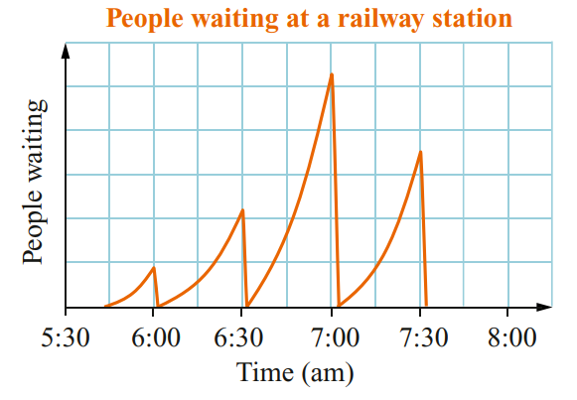
  - How often do trains arrive in this graph?

4 times
  - Describe in words how the number of people
varies for this time interval.

The number of people waiting increases at an increasing rate until a train arrives.
When a train comes, the people waiting decrease rapidly to zero at a constant rate

- The graph shows the number of cans of soft drink in the vending machine of a school.
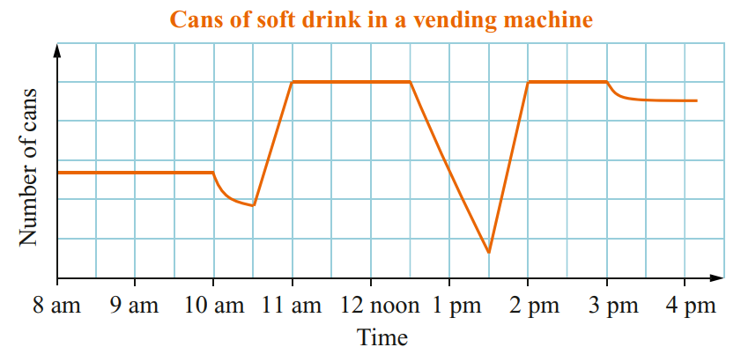
  - When do you think the recess and
lunch breaks occur in this school?

10 am and 12:30 pm
  - Describe in words how the number
of cans varies during the day.

The number of cans remains the same until 10 am when it decreases at a decreasing rate.
The number of cans then increases at a constant rate as the vending machine is filled, from 10:30 am to 11:00 am.
At 12:30 pm the number of cans decreases at a constant rate until 1:30 pm when the machine is refilled at a constant rate.
Some cans are removed at a decreasing rate between 3.00 pm and 3.30 pm.

- Match the graph with one of the stories.
  - Jenny climbs a hill at a steady speed and then runs down the hill stopping as quickly as possible.
B
  - Peter starts slowly and increases his speed until he is running as fast as possible then gradually slows.
D
  - Danielle gradually increases her speed and when at full speed continues to run.
C
  - Brook walks for a while then jogs for a while then runs for a while.
A
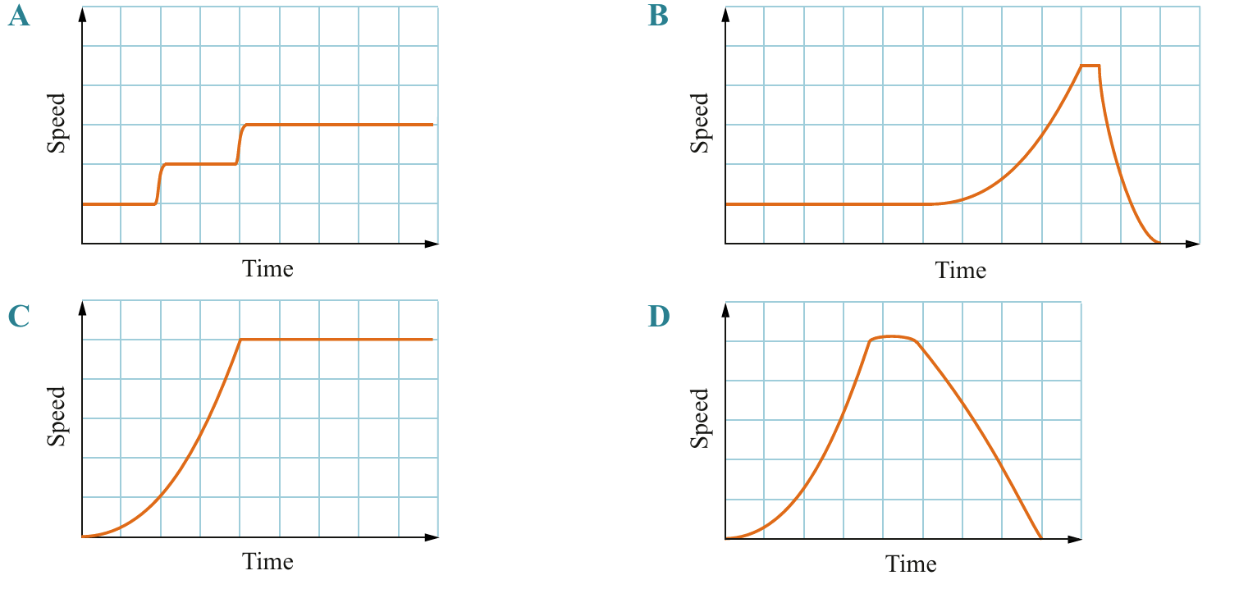

- A racing car travels around the three circuits shown. At sharp turns, the car must slow down. The graphs below show the speed of the car on the second lap of each of these circuits.
Match each graph with a circuit.
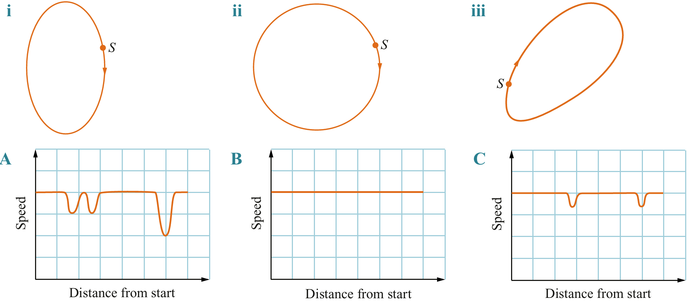

i – C, ii – B, iii – A

Graphs of Change

- Constructing Graphs of Rates of Change
A common question can ask you to construct a graph of a changing quantity.
For questions on height increase as you pour water at a constant rate:
- Larger cross-section: Slower increase in water height.
- Smaller cross-section: Faster increase in water height.
- Consistent cross-section: Constant rate of increase in water height.

Foundation
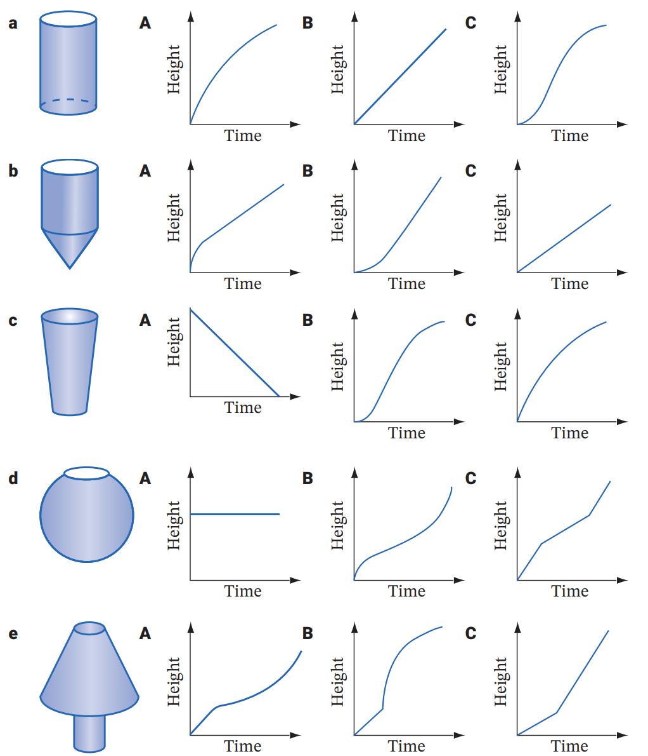
- For each container, select the graph that best describes the height of the water as it is poured at a constant rate into the container.

B

A

C

B

A

- Select the most appropriate graph for each scenario.
  - The speed of a car as it goes around a corner.
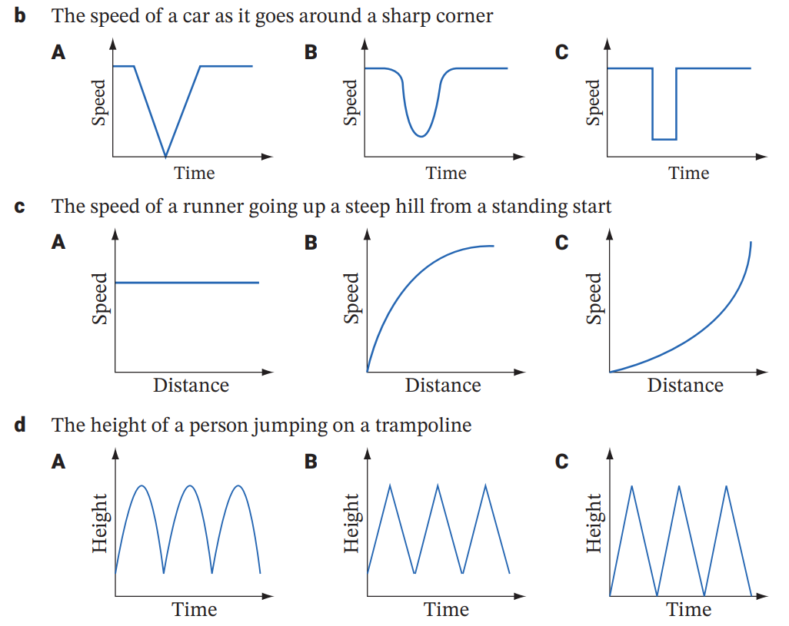

B
  - The speed of a runner going up a steep hill from a standing start.

B
  - The height of a person jumping on a trampoline.

A
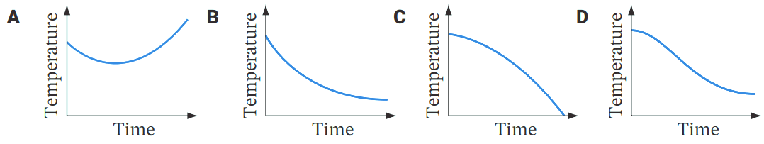
  - A bowl of hot soup is cooling. It loses heat quickly at first but as time passes, it loses heat more slowly until it is at room temperature.

B
- Match each distance−time graph (A − D) with the journey described (a − d).
- A soccer player runs at a steady speed across the field, stops briefly  to avoid a tackle and then accelerates farther away. | B
- A rocket stage 1 booster accelerates to huge speed, then detaches  and quickly decelerates, then accelerates as it falls towards Earth.  Finally, a parachute opens and it slows, falling to Earth at a steady speed. | D
- A motorbike moves at a steady speed, then accelerates to pass a car,  then brakes and decelerates, coming to a stop at traffic lights. | C
- A school bus accelerates away from the bus stop, then moves at a  steady speed and then decelerates and stops. | A
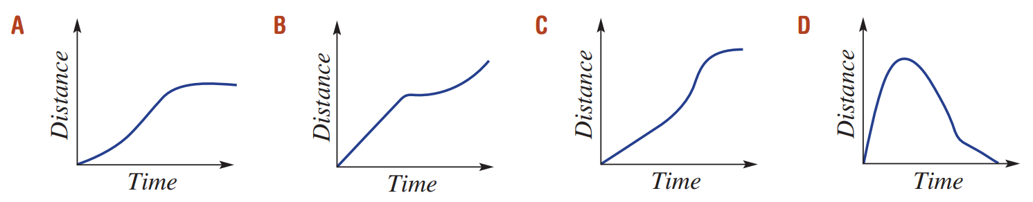

- Match each story to its graph(the variables are given in brackets).
- People were purchasing from the vending machine until it broke down.  (number of cans in machine, time) | H
- The tank was half full of water all day.  (depth of water, time) | A
- The cost of a mobile phone call is charged at a constant rate.  (cost, time) | C
- Jo was watching a movie but stopped to take a phone call halfway.  (amount of movie seen, time) | F
- Water level rises rapidly at a constant rate, then steadily falls at a constant rate and stay at a constant low. (water level, time) | I
- A taxi fare includes the hire charge plus a constant amount per kilometre. (cost, kilometres travelled) | D
- The car is consuming petrol at a steady rate until it runs out of fuel. (litres in tank, time) | B
- Dario jogs at a steady rate, then stops and rests.  (distance travelled, time) | E
- Jordan jogs at a steady rate, then walks home.  (distance travelled, time) | G
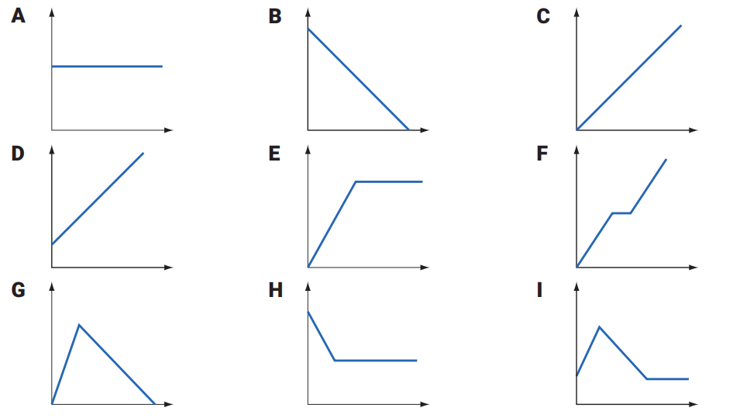

Mastery
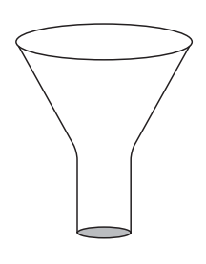
- 2022 HSC Standard 1 Band 5
The diagram shows a container, closed at the base.
It is to be filled with water at a constant rate.
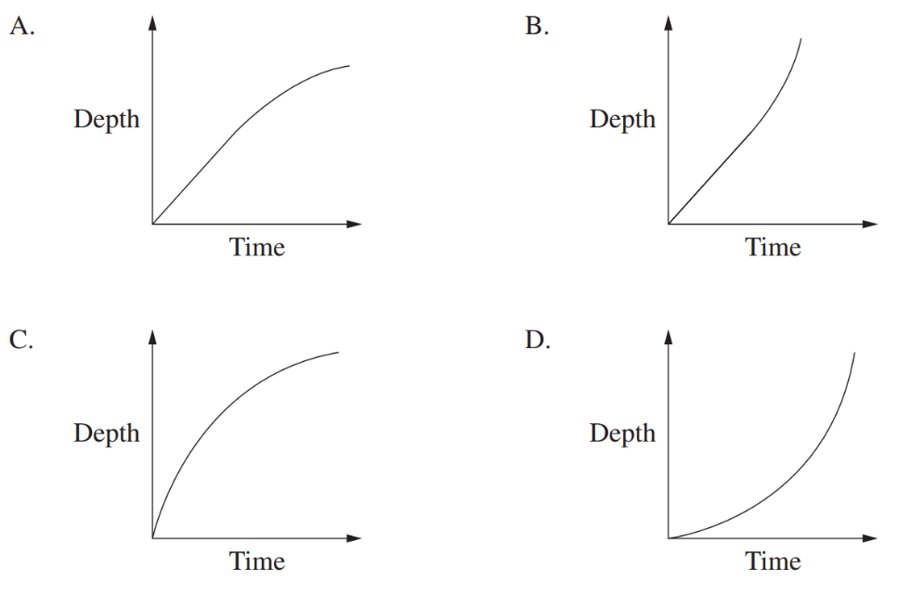
Which graph best shows the depth of water in the container as time varies?

A
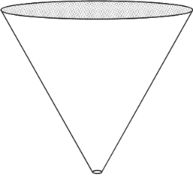
- 2019 HSC Standard 1 Band 5
The container shown is initially full of water.
Water leaks out of the bottom of the container at a constant rate.
Which graph best shows the depth of water in the container as time varies?
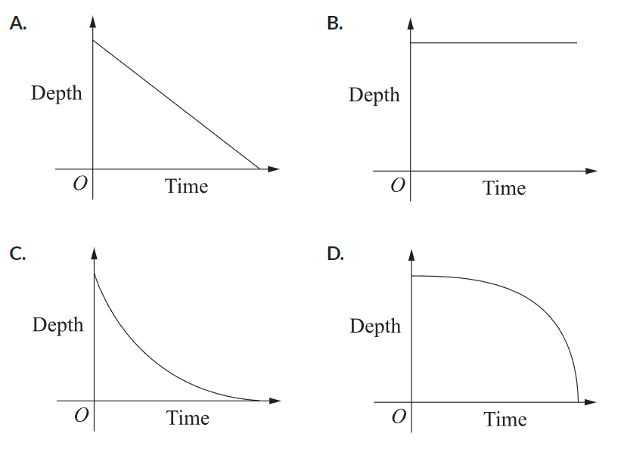

D

- Draw graphs to illustrate these scenarios. Label the axes.
- The price of an object used to be free, rose quickly at first, and is now rising at a decreasing rate.  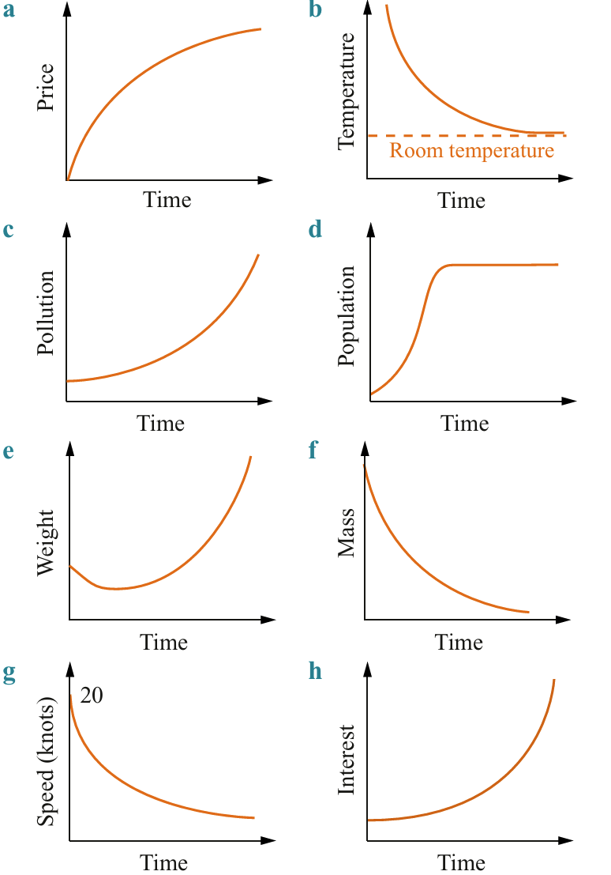 | - The temperature of a cup of coffee decreases quickly at first and then more slowly until it reaches room temperature.
- The level of pollution in the atmosphere of a city starts low and is increasing at an increasing rate. | - The population of a town increased rapidly when a new factory opened and then it remained steady.
- The weight of a baby decreased slightly after its birth and then increased at an increasing rate. | - When radioactive material decays, the amount of material present decreases at a decreasing rate.
- When a passenger liner travelling at 20 knots turns off its motor, the speed of the ship decreases at a decreasing rate. | - The amount of interest earned increases at an increasing rate when money is invested at a compounding interest rate.

Speed-Time Graphs

- Acceleration and Deceleration
Speed is the rate of change of distance over time,
E.g. A car travelling on a highway at 90 km per h (km/h).
Acceleration is the rate of change of speed over time,
E.g. An object falling due to gravity accelerating at 9.8 metres per second, per second (m/s²).
Acceleration is the gradient of a speed-time graph.
Negative acceleration is called deceleration.

- Example Calculate acceleration and deceleration from a speed-time graph
Consider the speed-time graph of a car.  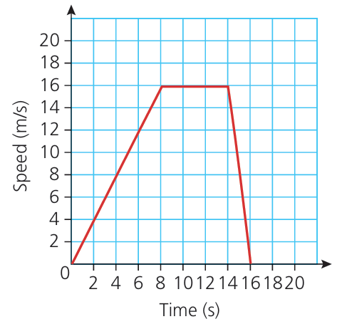 | - Calculate the acceleration during the first 8 seconds  $$m=\frac{16}{8}=2 m/s^{2}$$  - Explain why the acceleration is 0 between 8 and 14 seconds.  The gradient is 0, this means the speed is constant, no change in speed means no acceleration.  - What is the acceleration during 14 to 16 seconds?  $$m=\frac{-16}{2}=-8 m/s^{2}$$

- Guided Practice
Consider the speed-time graph of a car below.
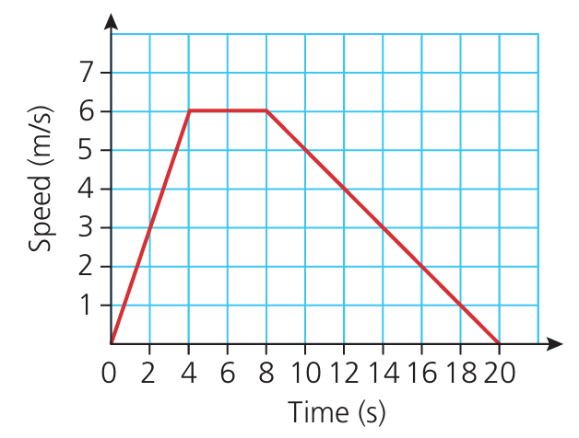 | - Calculate the acceleration during the first four seconds.  1.5 m/s²  - Calculate the acceleration during the next four seconds.  0 m/s²  - Calculate the acceleration during the final 12 seconds.  $-$ 0.5 m/s²
- Distance Travelled
Since $distance=speed×time$,
the area under a speed-time graph is the distance travelled.

- Example Calculate distance travelled from a speed-time graph
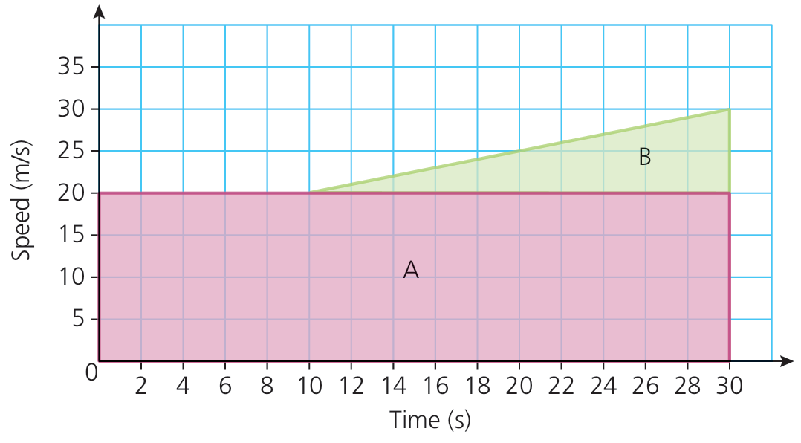
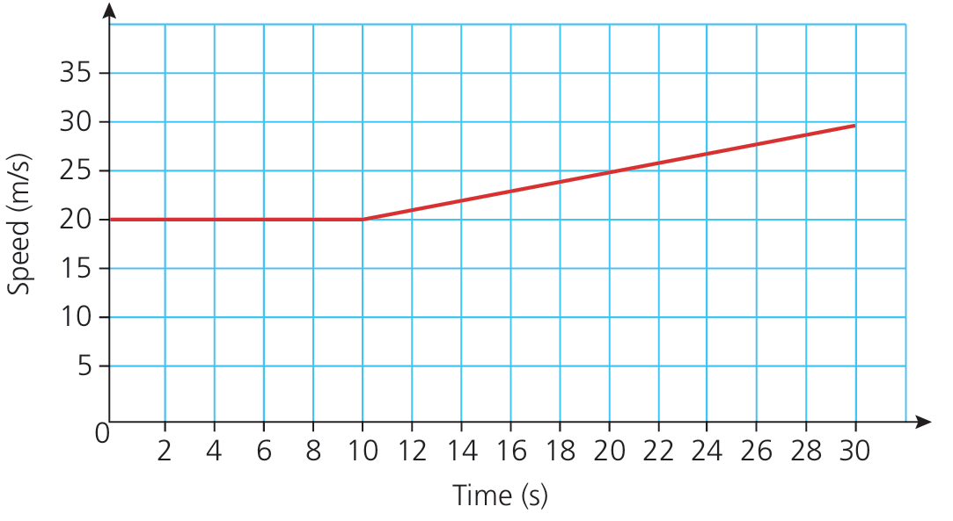
Consider the speed-time graph of a car. Calculate the distance travelled by the car.

$$Area A = \left(20×30\right)=600 m$$
$$Area B = \frac{1}{2}\left(20×10\right)=100 m$$
Total distance: 700 m

- Example Calculate distance travelled from a speed-time graph
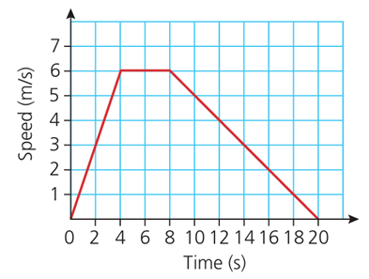
Consider the speed-time graph of a car. Calculate the distance travelled by the car.

72 m

- Key Ideas
- ……………… is the rate of change of speed. To find acceleration, we find the gradient of a ……………-………… graph.
- The area under a speed-time graph is the …………………… travelled. This is because $distance=$ …………… $×$ ………………

Foundation
- Using the graphs below, calculate the acceleration/deceleration in each case in m/s².
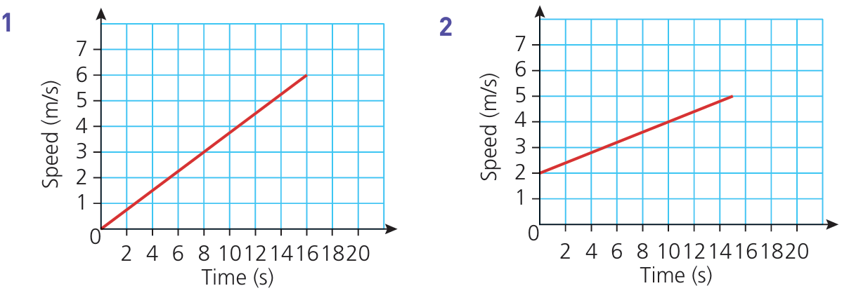  0.375 m/s² | 0.2 m/s²
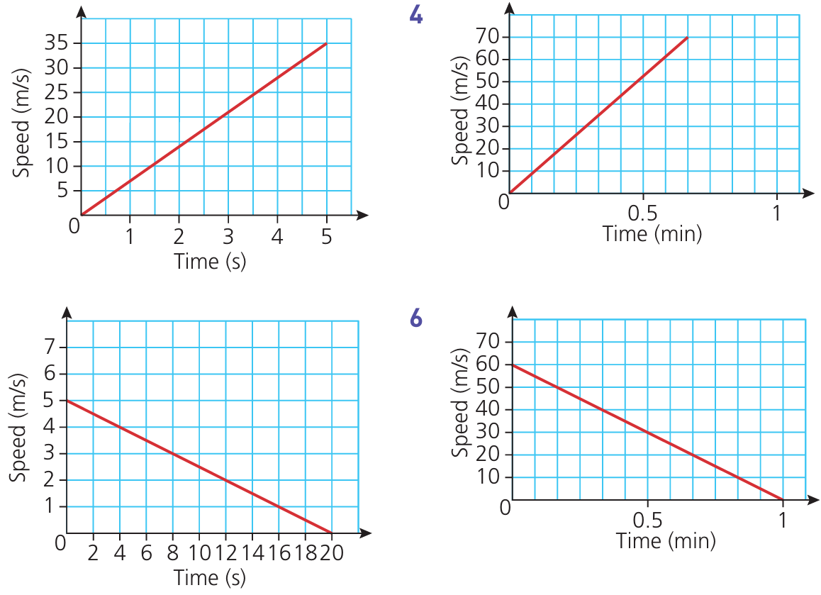  7 m/s² | 1.75 m/s²
$-0.25$ m/s² acceleration or  0.25 m/s² deceleration | $-1$ m/s² acceleration or  1 /ms² deceleration

- Sketch a graph to show:
- an aeroplane accelerating from rest at a constant rate of 5 m/s² for 10 seconds.  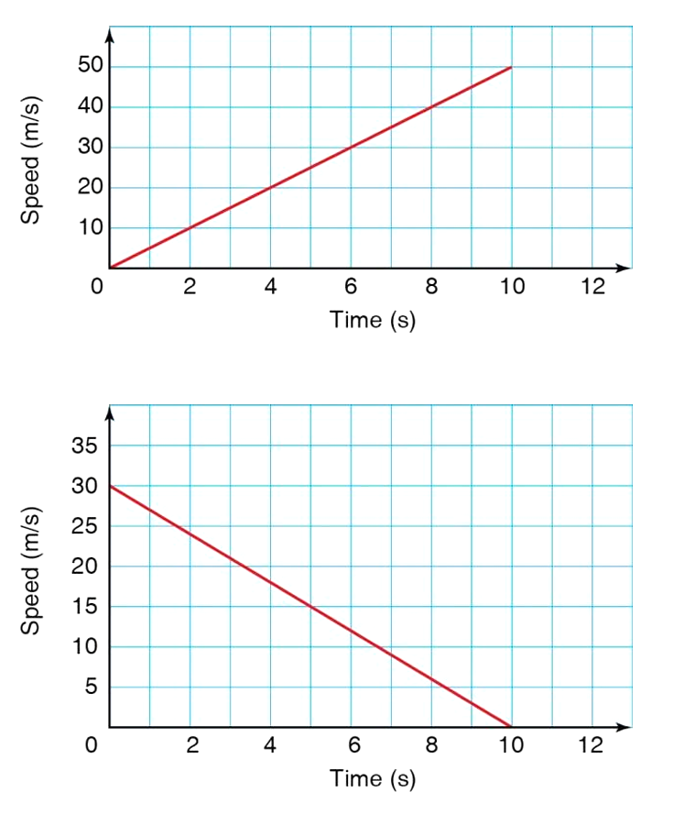 | - A train travelling at 30 m/s starts to decelerate at a constant rate of 3 m/s² until it stops.

Development
- The speed−time graph represents a cheetah seeing a gazelle and chasing it.
The cheetah catches the gazelle
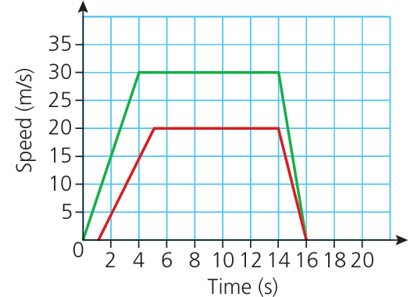
  - Does the top graph represent the cheetah or the gazelle?

cheetah
  - Calculate the cheetah’s acceleration in the initial stages of the chase.
7.5 m/s²
  - Calculate the gazelle’s acceleration in the initial stages of the chase.
5 m/s²
  - Calculate the cheetah’s deceleration at the end.
15 m/s²

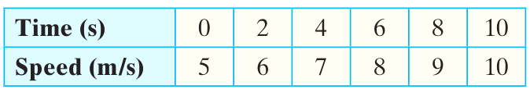
- The table below gives the speed of a boat over a 10-second period.

  - Plot a speed-time graph for the 10 second period.
  - Calculate the acceleration of the boat.
  - Calculate the total distance travelled during the 10 seconds.
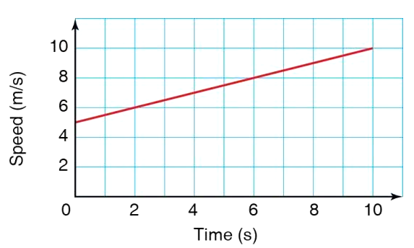

b) 0.5 m/s²
c) 75 m
- A cyclist travelling at 6 m/s applies the brakes and decelerates at a constant rate of 2 m/s²
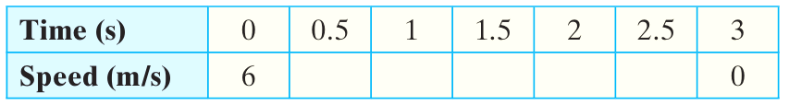
  - Complete the table below.

5, 4, 3, 2, 1
  - Plot a speed-time graph for the 3 seconds shown in the table above.
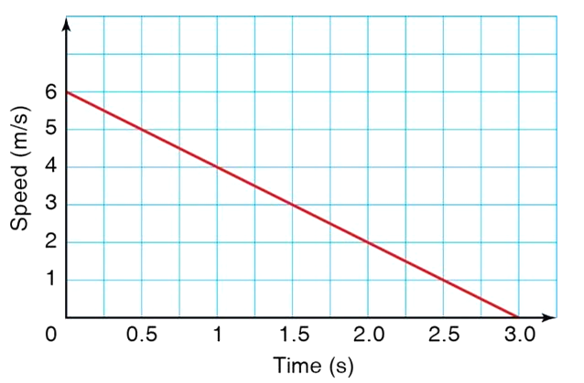
  - Calculate the distance travelled during the 3 seconds of deceleration.

c) 9 m

- A car accelerates as shown in the graph.
  - Calculate the rate of acceleration in the first 40 seconds.
  - Calculate the distance travelled over the 60 seconds shown.
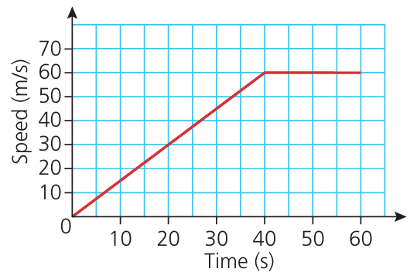
  - After what time had the motorist travelled half the distance?

a) 1.5 m/s²
b) 2400 m
c) 40 s

- The graph represents the cheetah and gazelle from before.
  - Calculate the distance run by the cheetah during the chase.
  - Calculate the distance run by the gazelle during the chase.
  - How far apart were the two animals when the chase started?

a) 390 m
b) 240 m
c) Since they ended at the same place, they started (390 – 240 = 150 m apart)

